**Exercise 11**

Write a HTML code to create a web page with heading. The heading shall be displayed at the top-center of the page and the image shall be at the centre, just below the haeding.

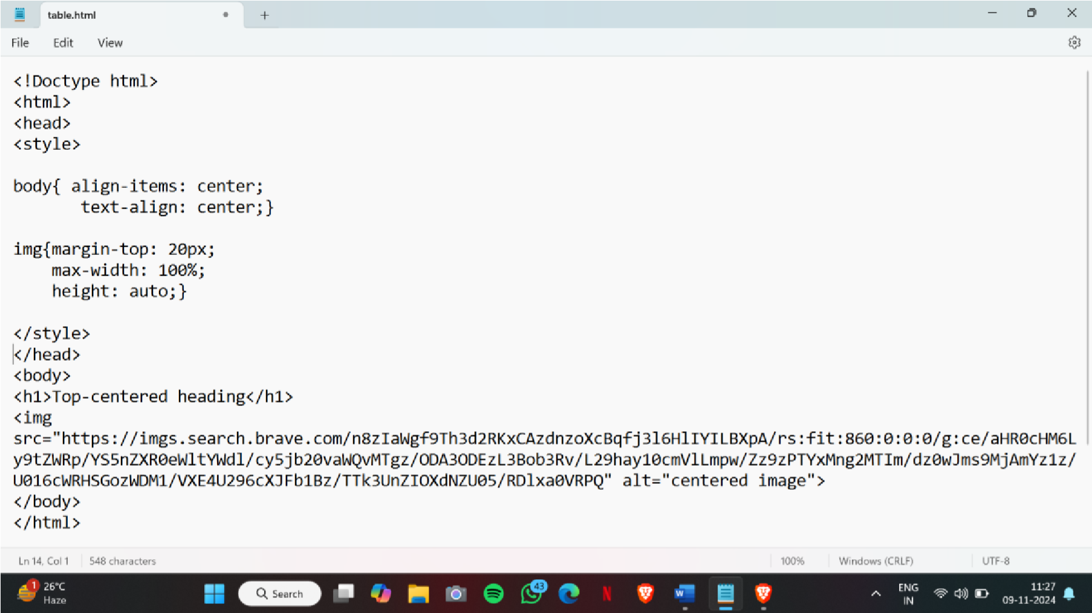

OUTPUT:

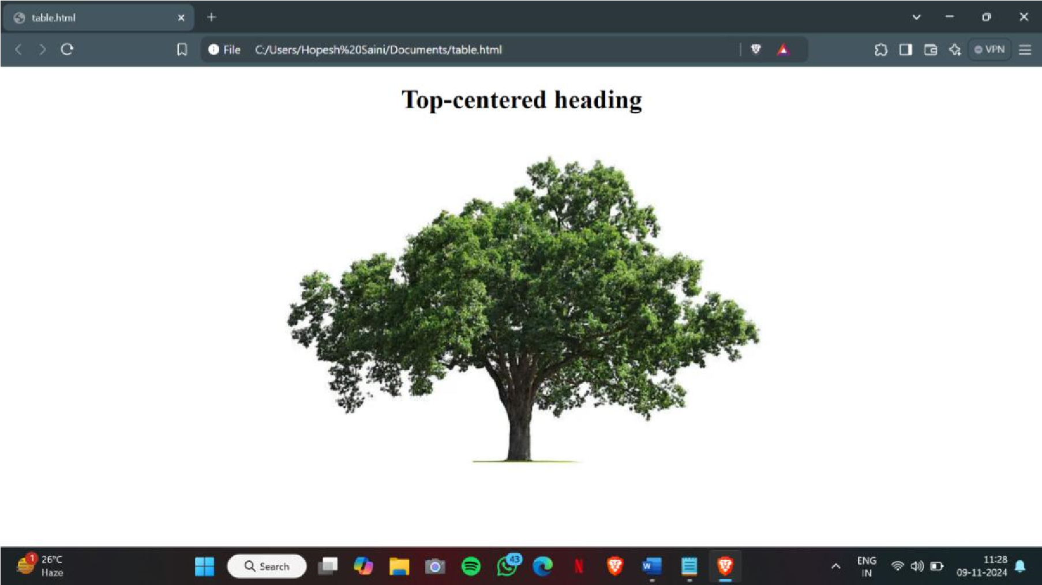

# EXERCISE 12

Write a HTML code using multimedia tags.

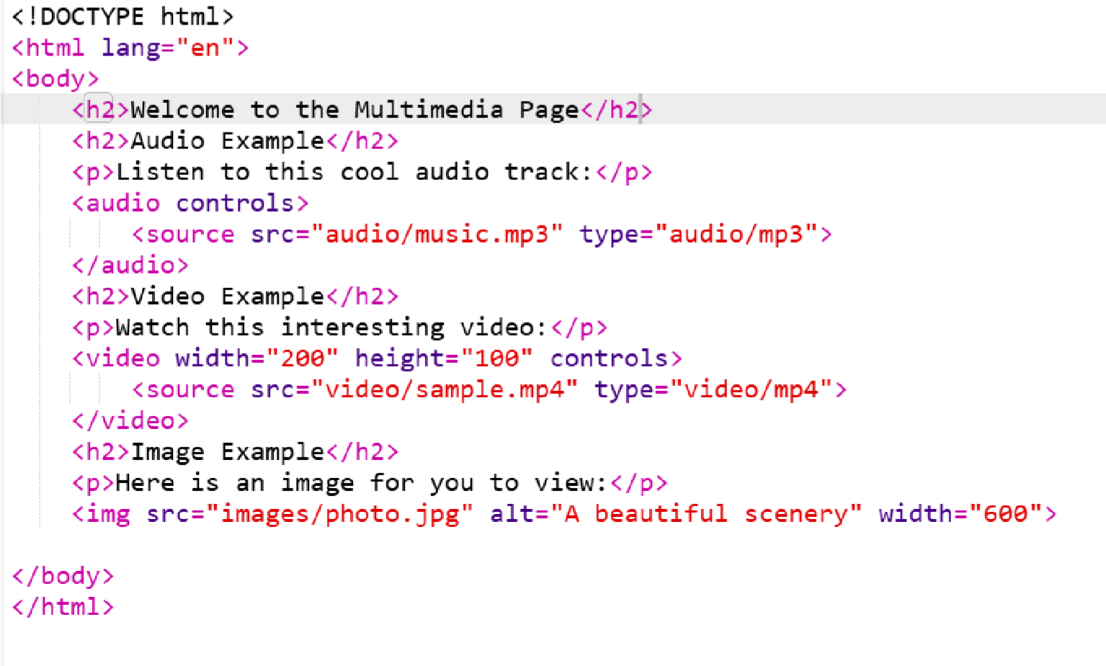

OUTPUT:

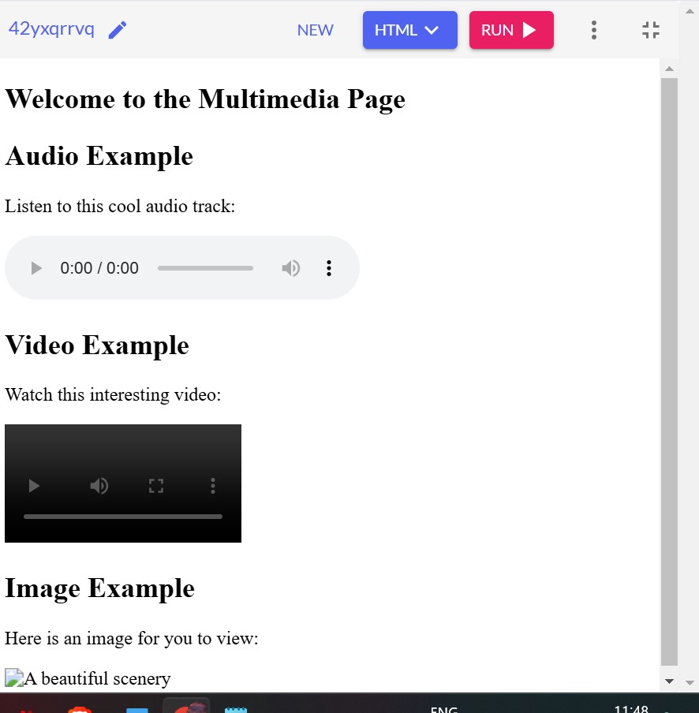

# EXERCISE 13

Create a table using rowspan and colspan taking example of

student record.

OUTPUT:

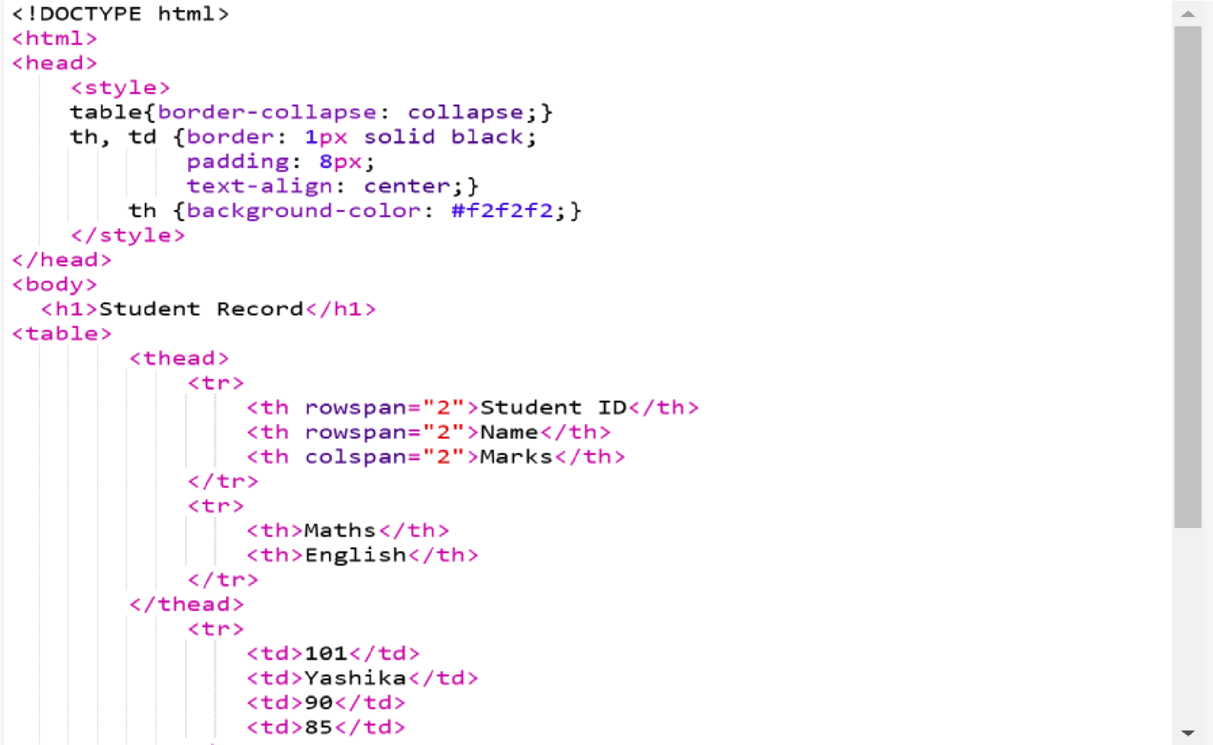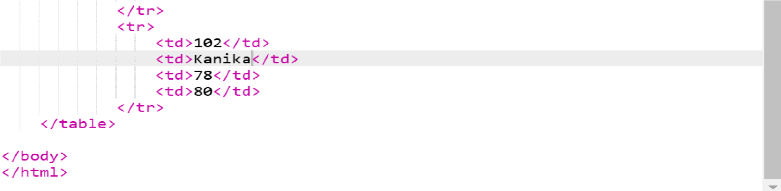

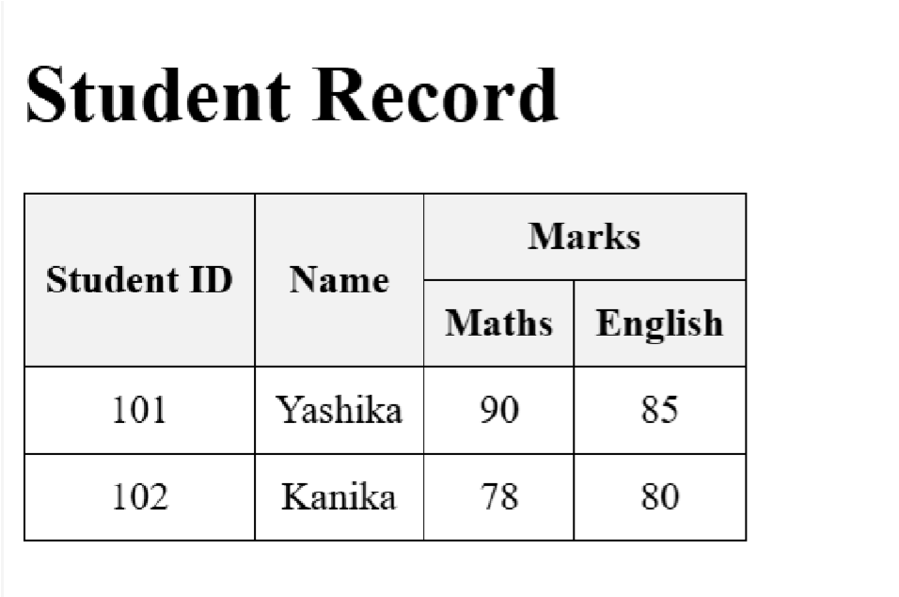

# EXERCISE 14

Write HTML code using table tag <table> and cellpadding and cell spacing as its attributes

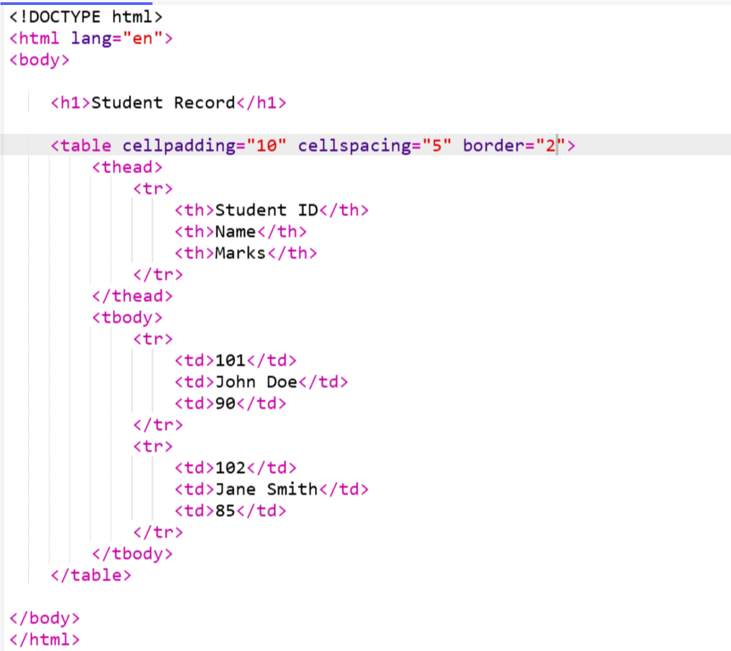

OUTPUT:

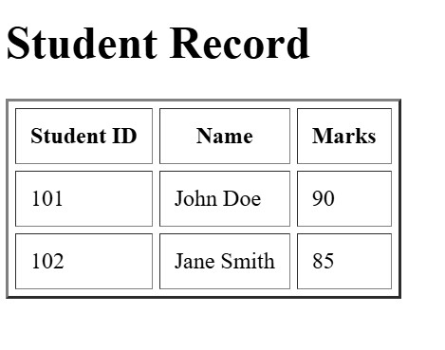

# EXERCISE 15

Create unordered, ordered and definition lists taking example of

your subjects in MCA IST, IInd and IIIrd sem.

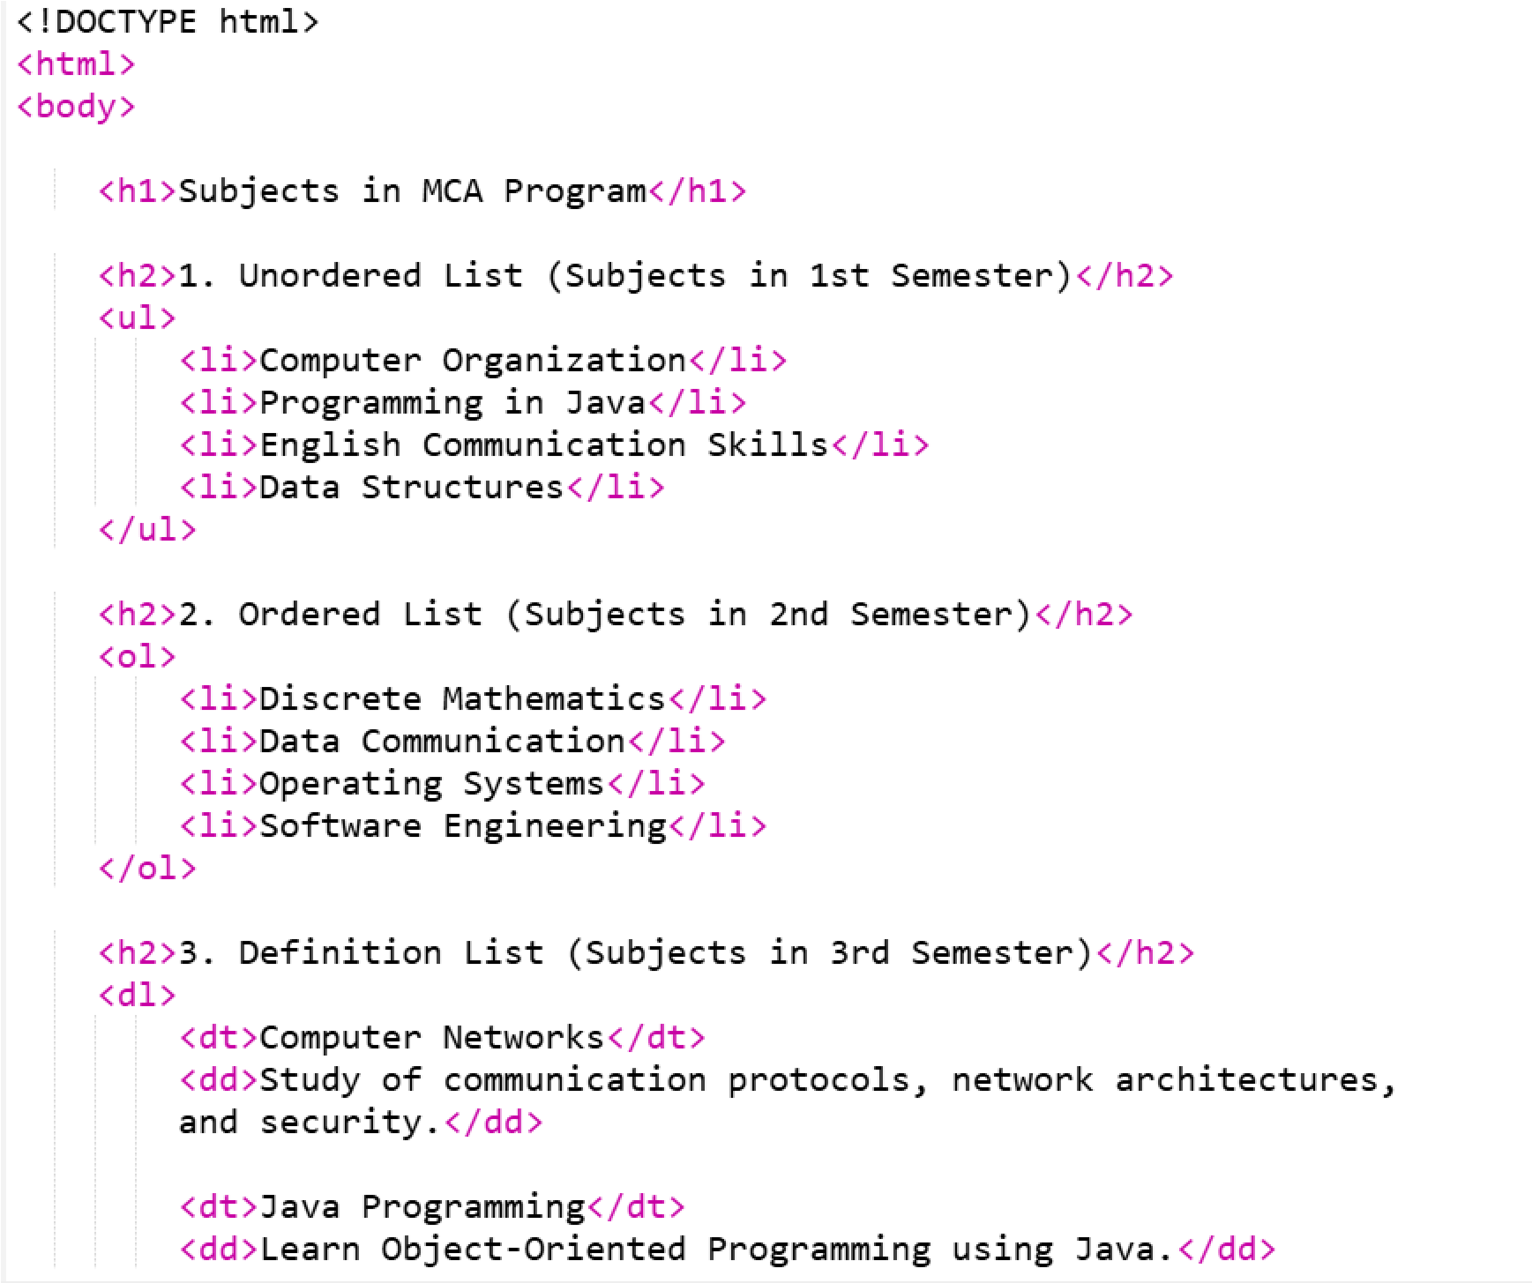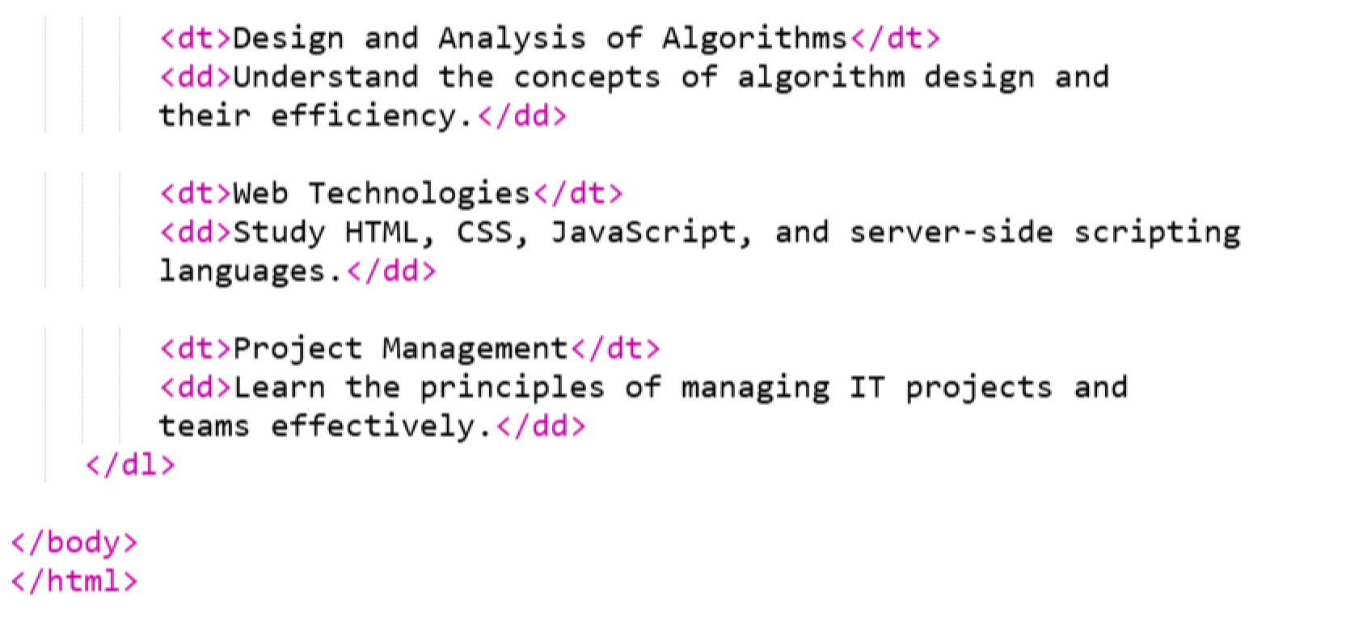

OUTPUT:

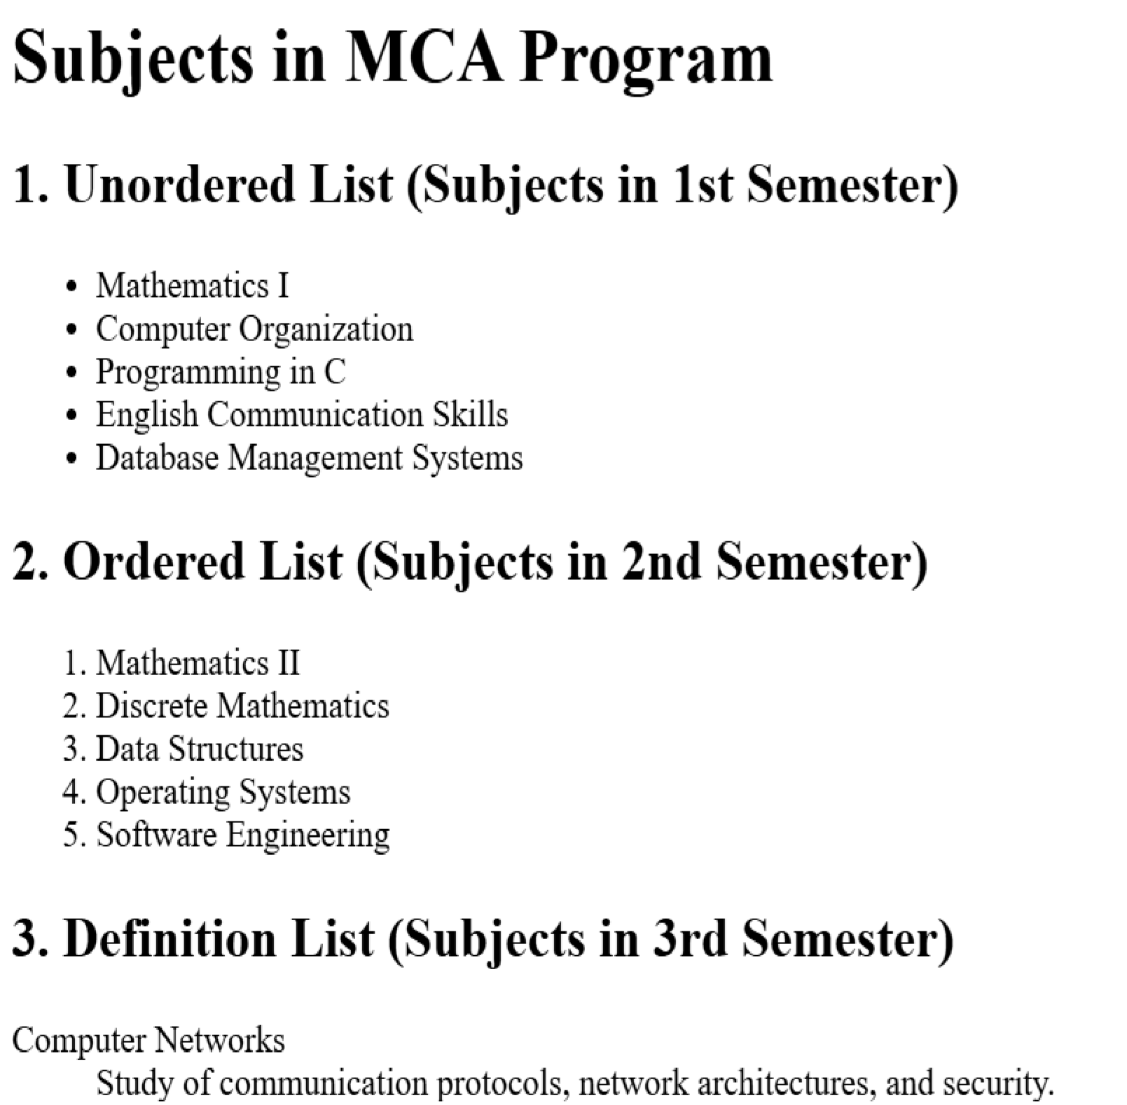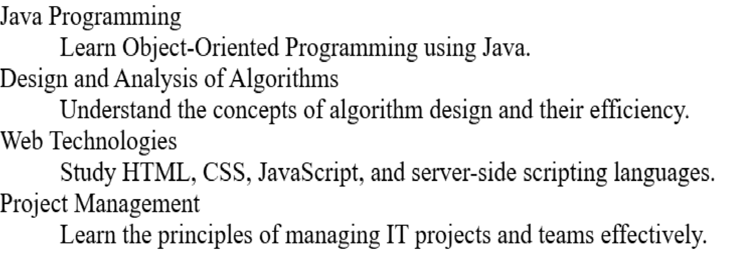

Write HTML code using <frameset> and <frame> tag with all its attributes

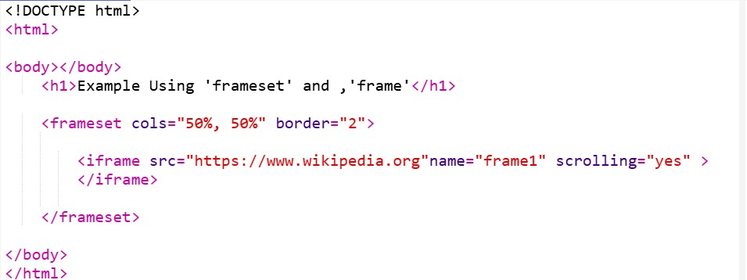

OUTPUT:



Write HTML code to design a form in html using controls and buttons such as Textbox, Text Area, password, submit button, browse button, drop down menu

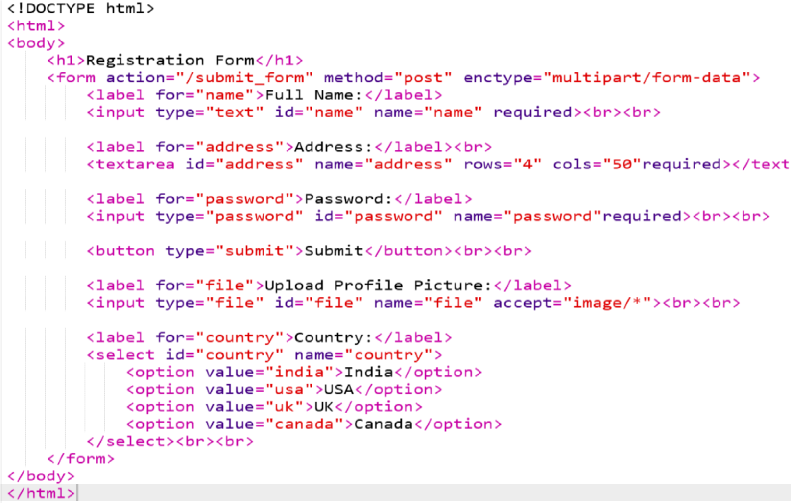

OUTPUT:

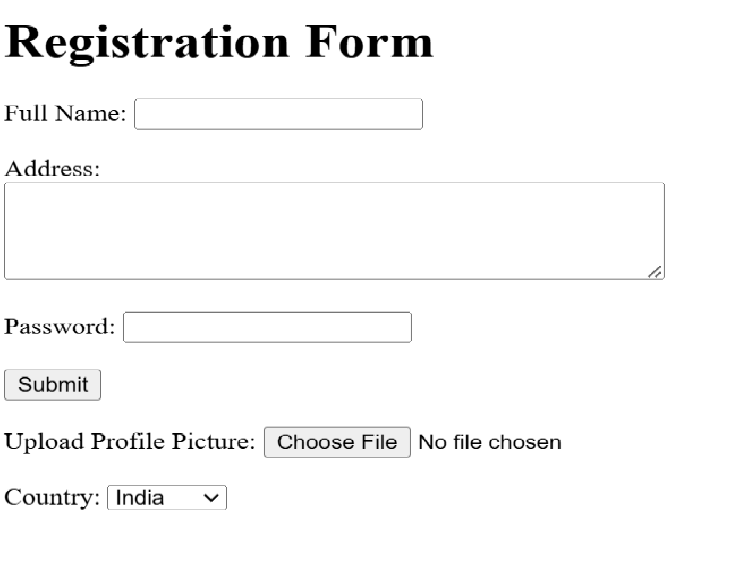

Write HTML code to design a Registration form in html.

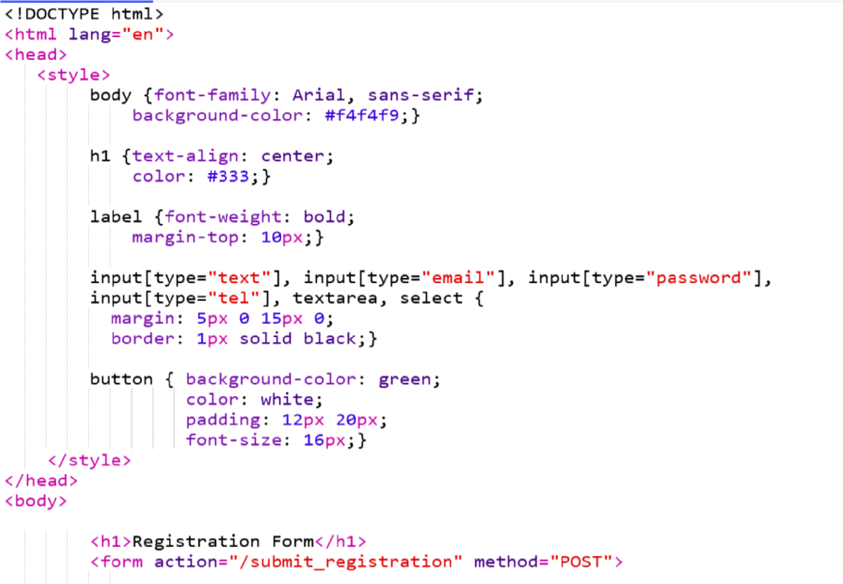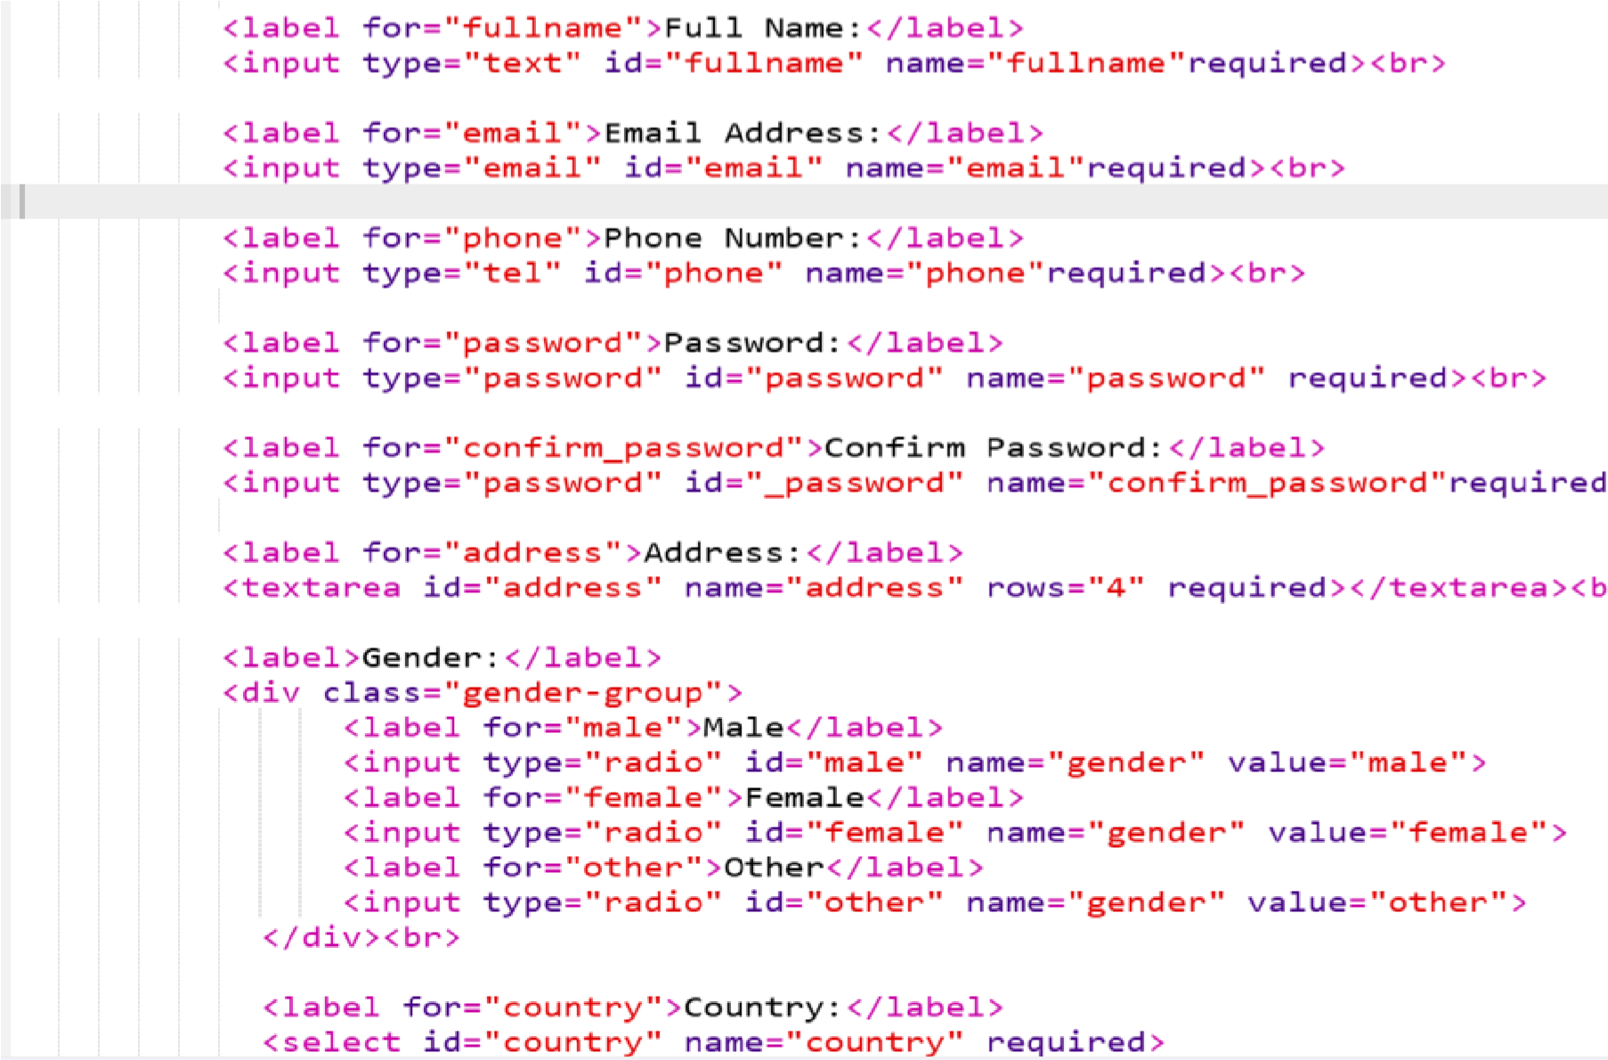

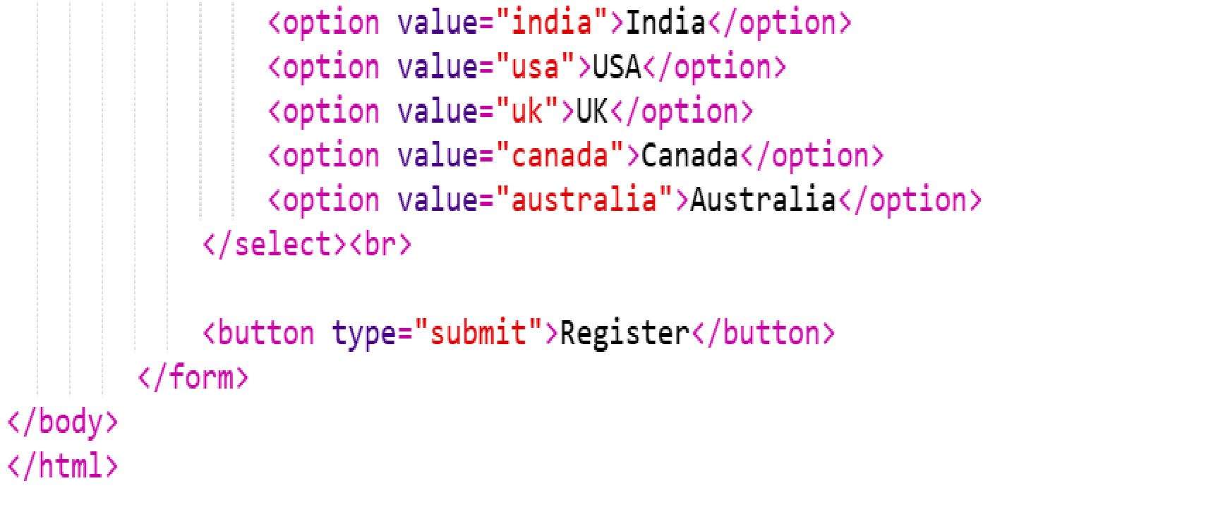

OUTPUT:

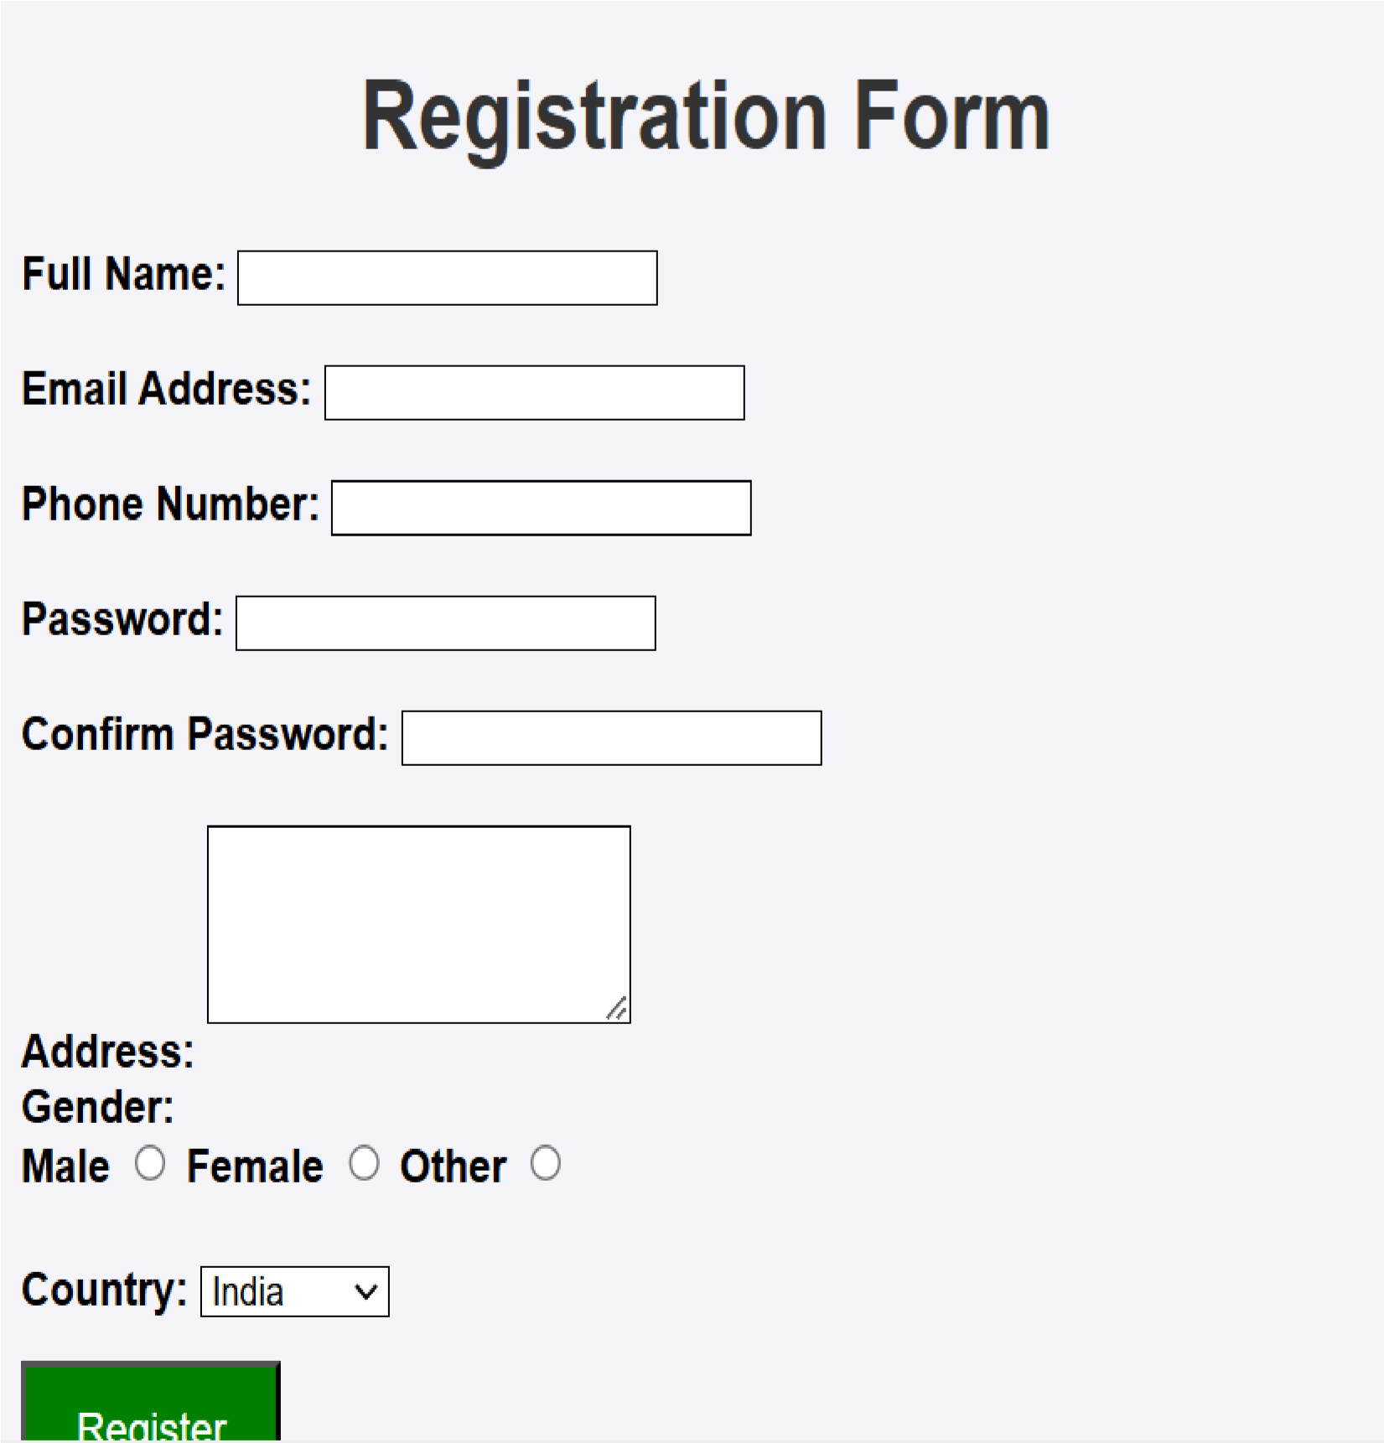

# EXERCISE 19

Write HTML code to

de

sign a student admission form in HTML

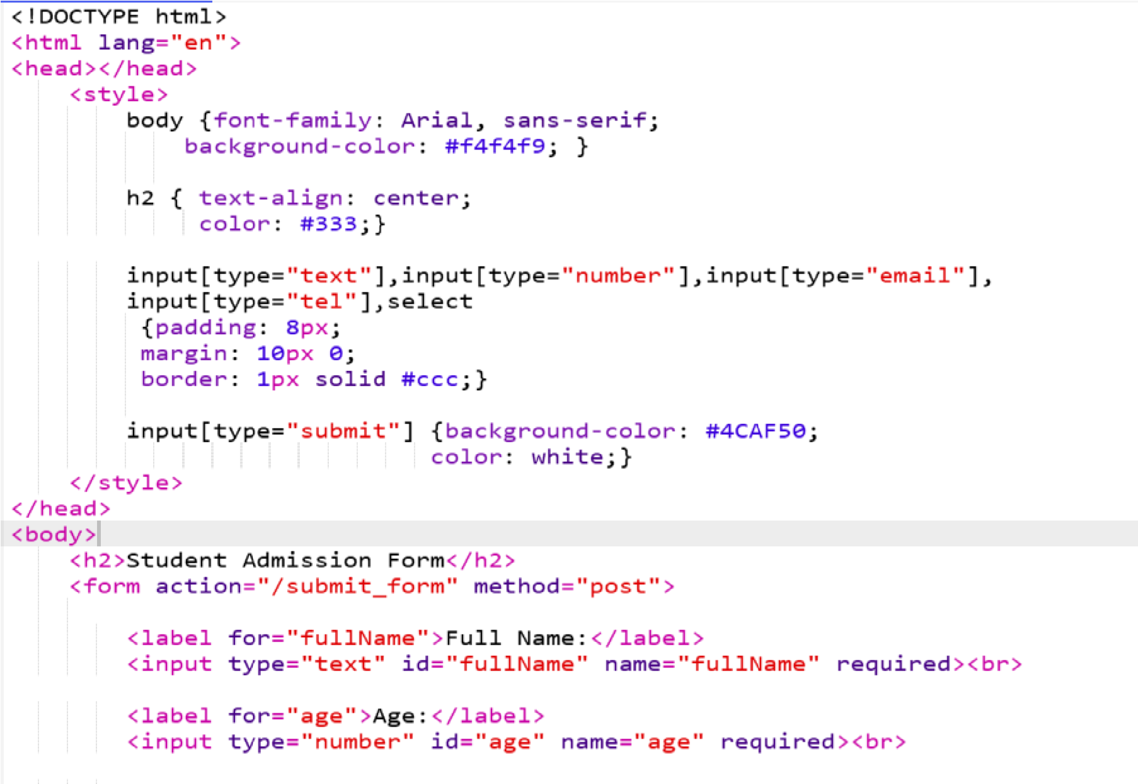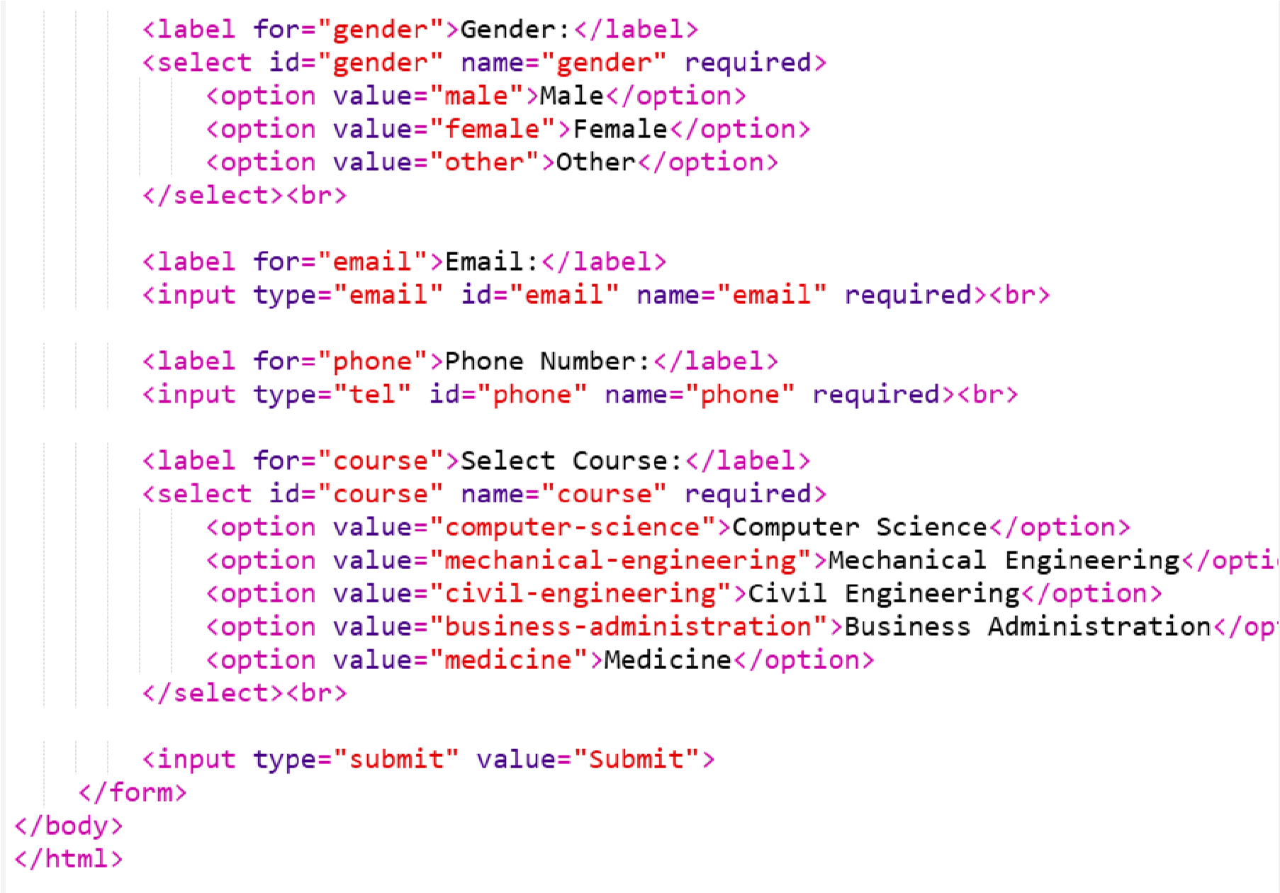

OUTOUT:

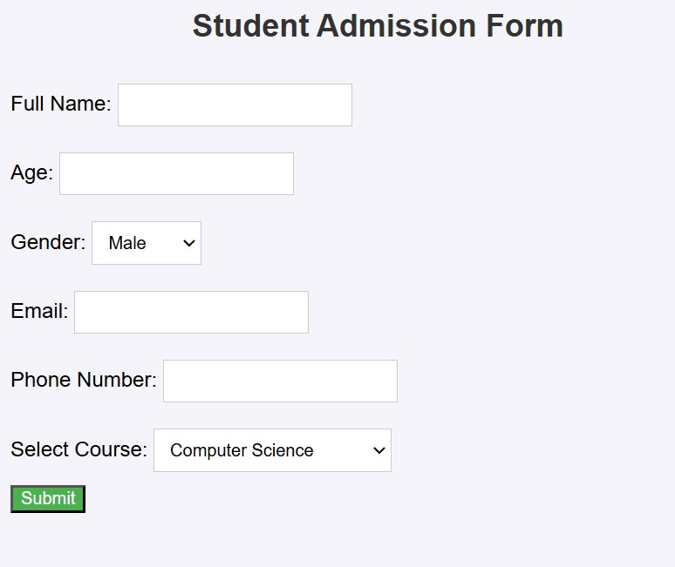

# EXERCISE 20

Create a proper home page of your own using any components and styles

CSS:

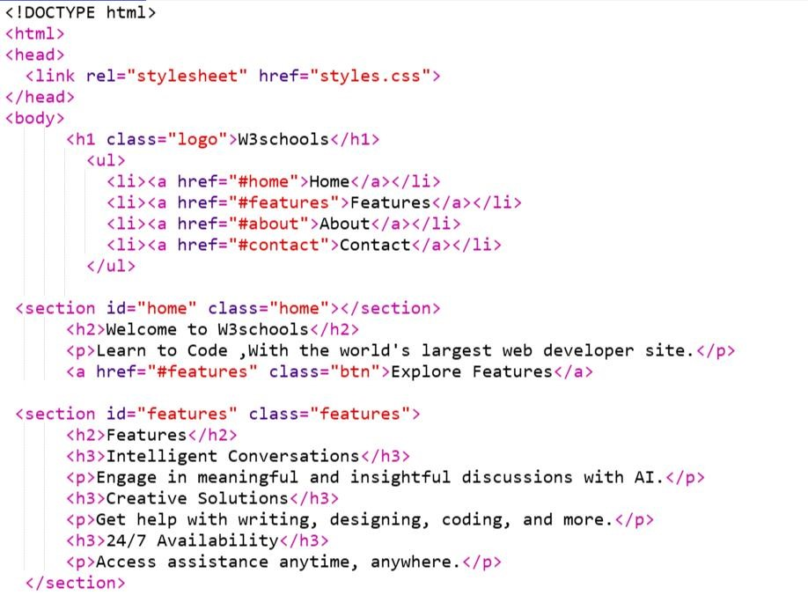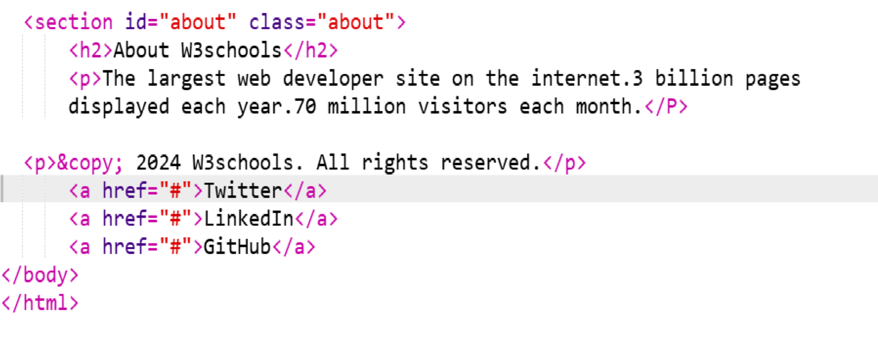



OUTPUT;

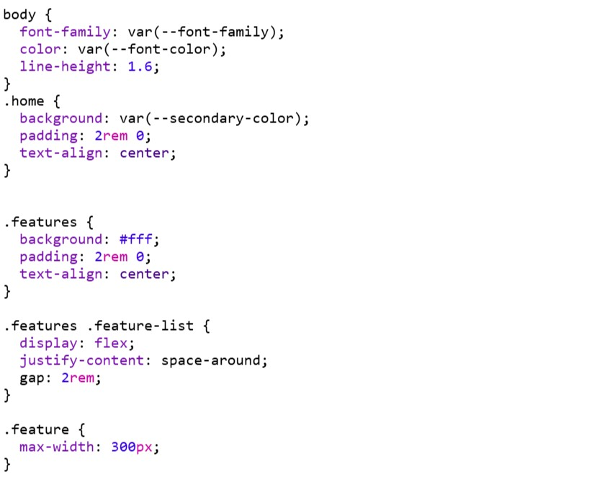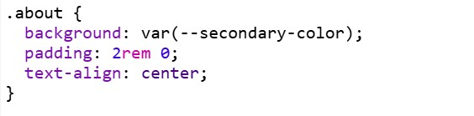



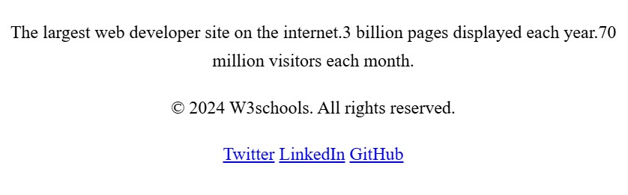

# EXERCISE 21

Write HTML code for including local hyperlinking in a web page

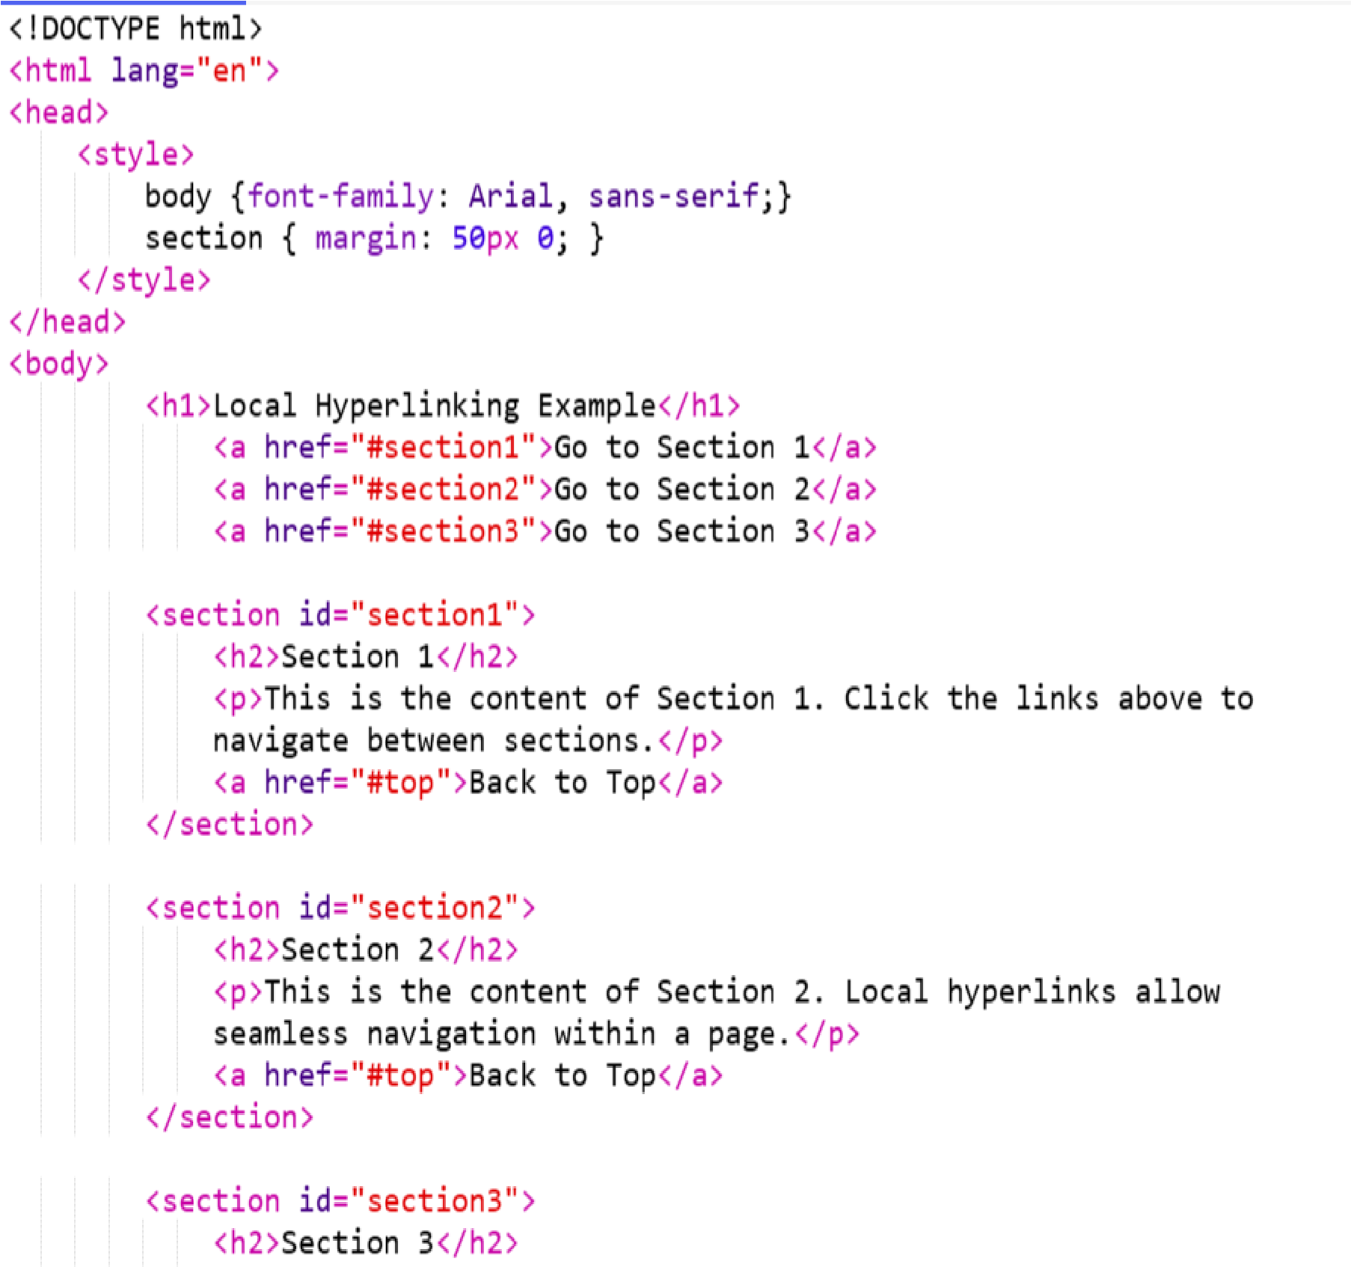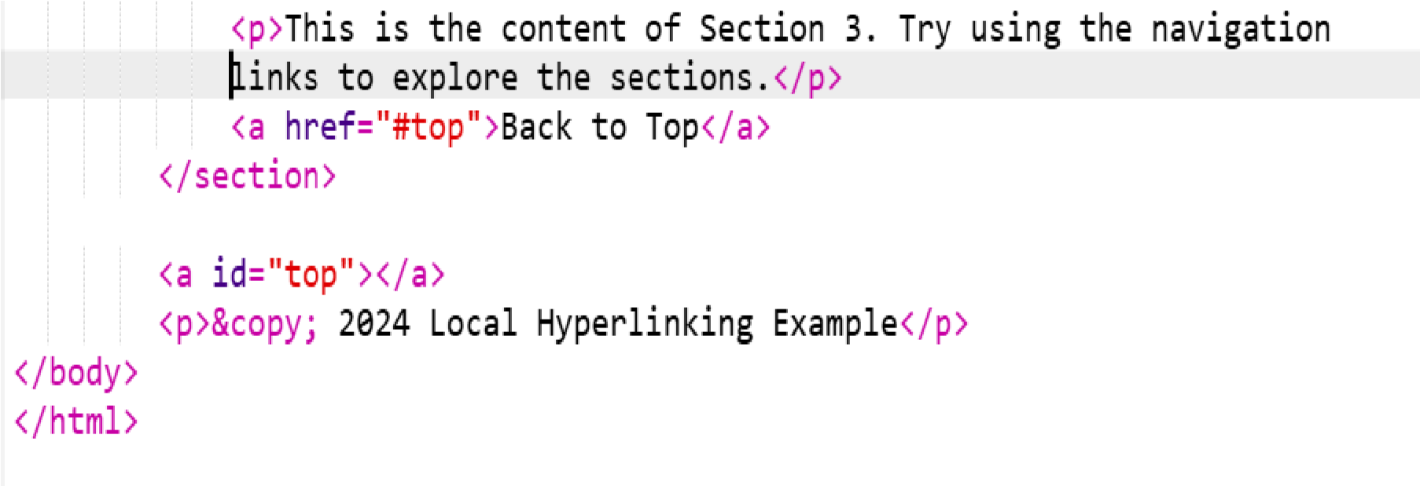

OUTPUT:

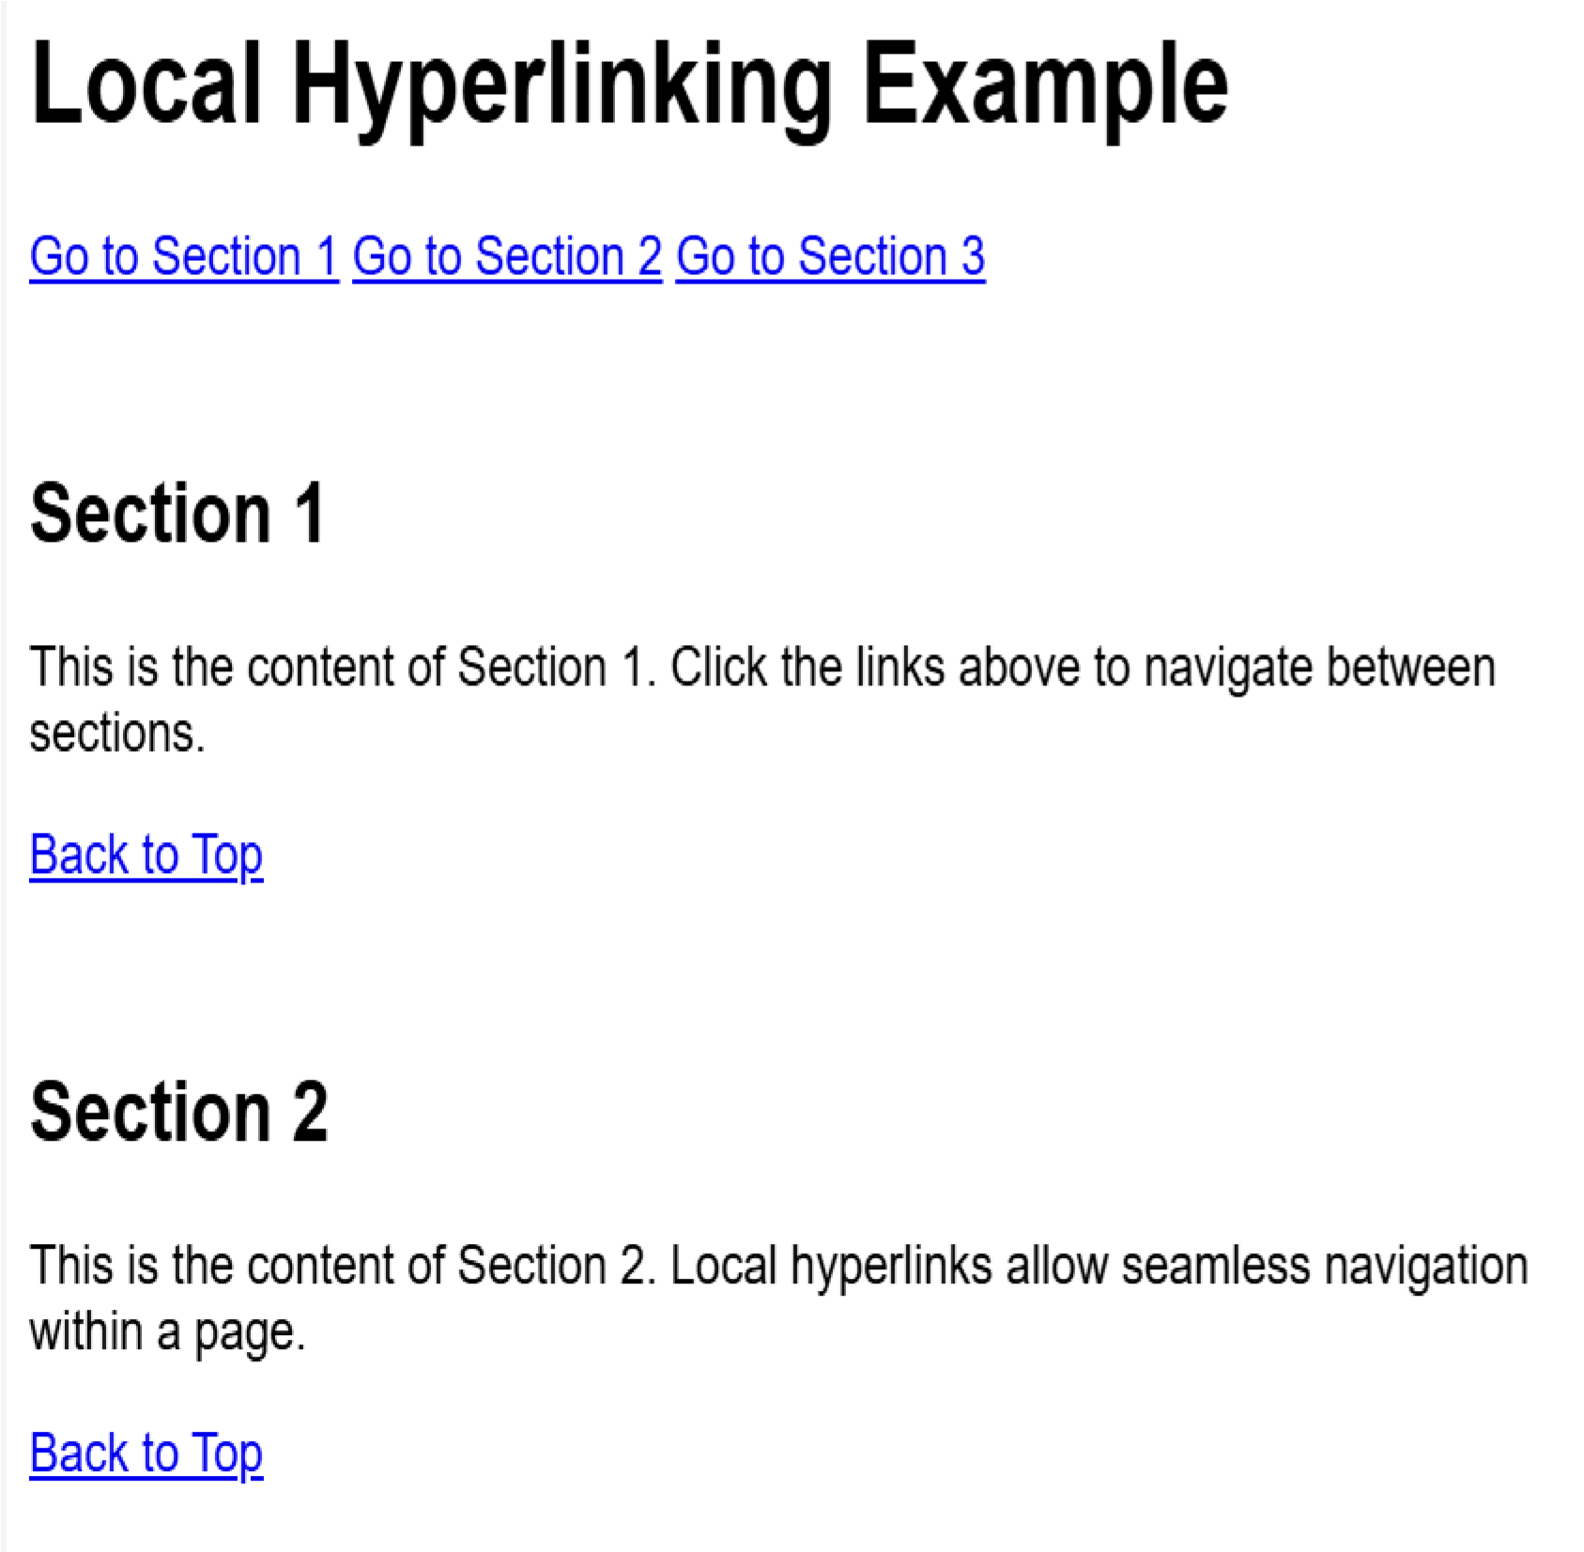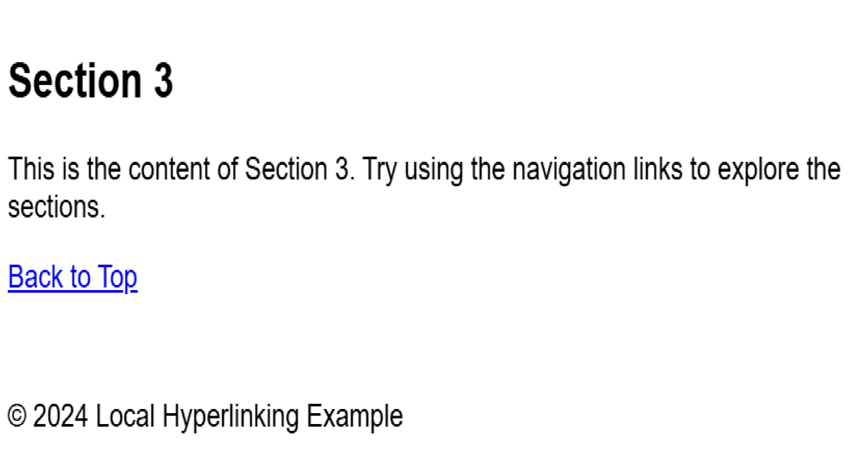

Write HTML code for including External hyperlinking in a web page.

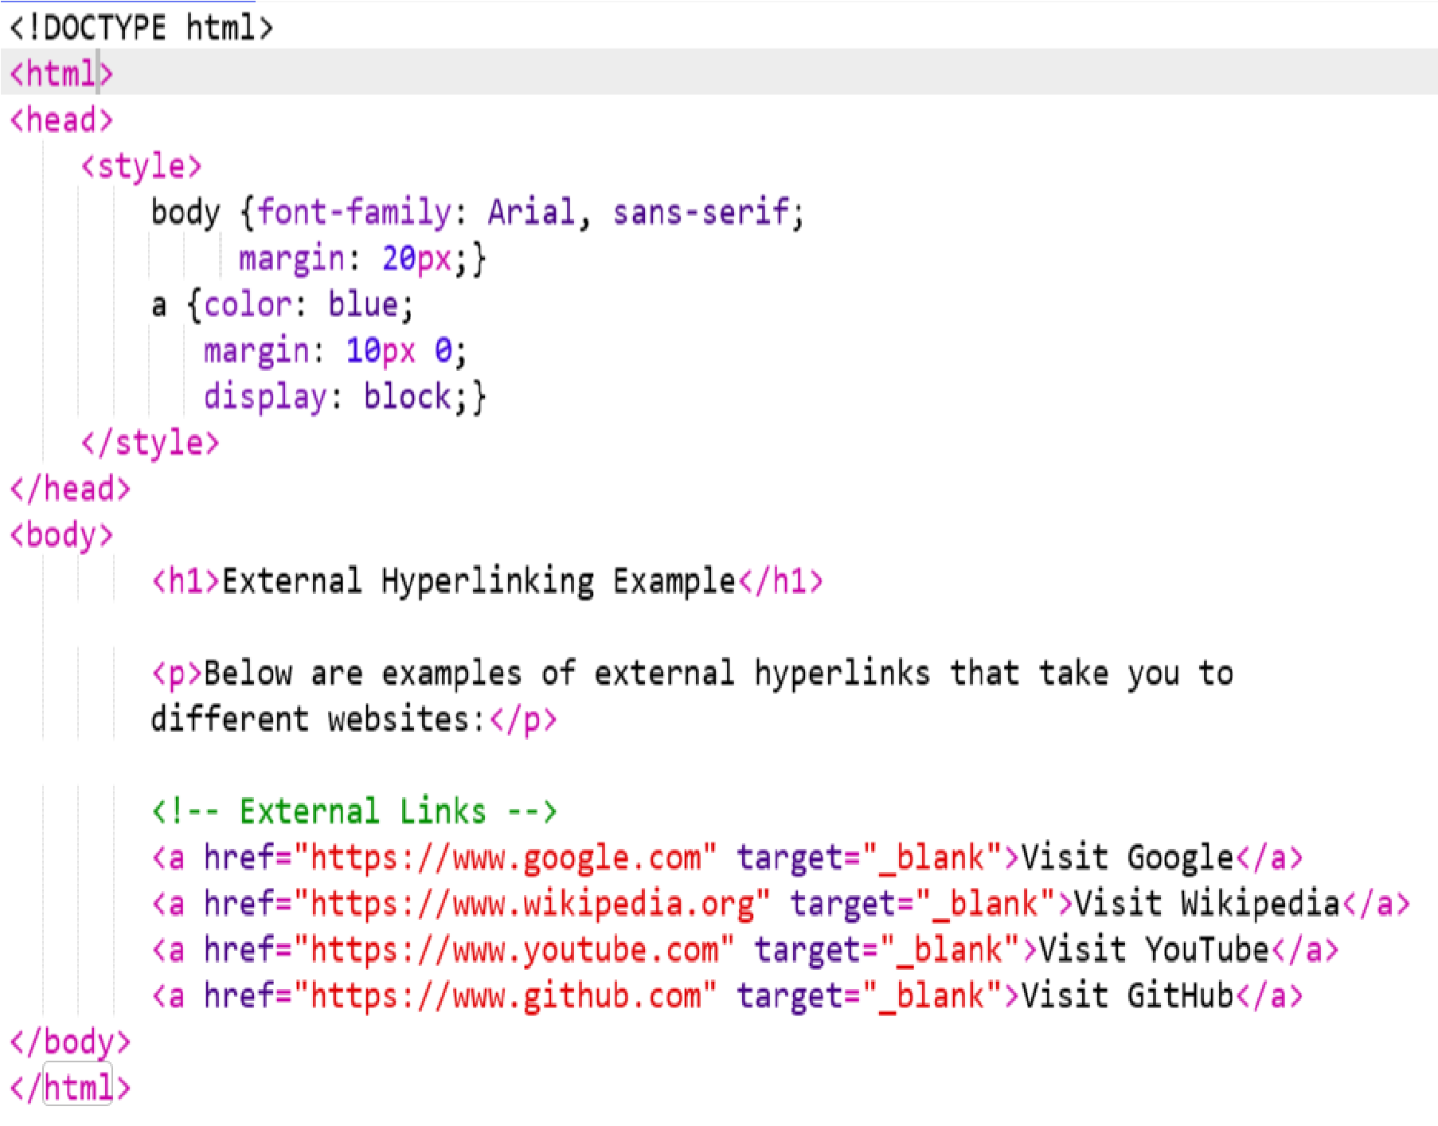

OUTPUT:

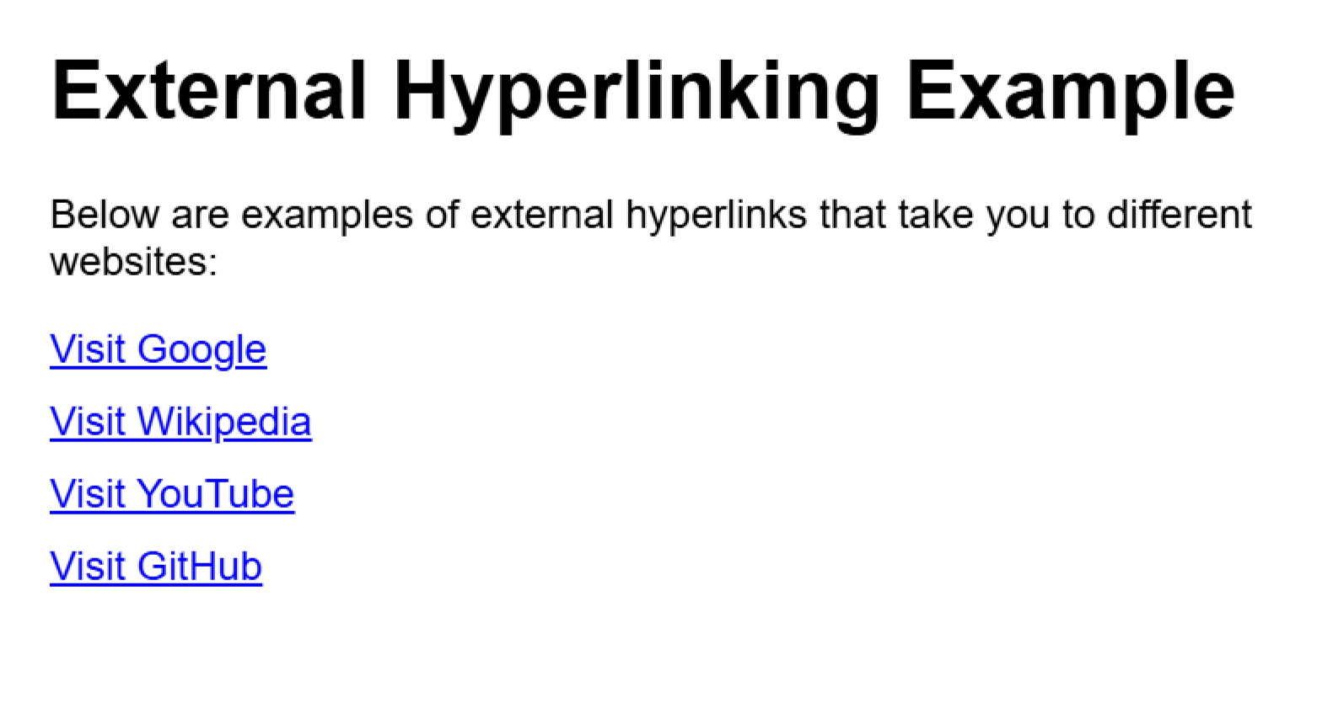

Write HTML code for including inter hyperlinking in a web page.

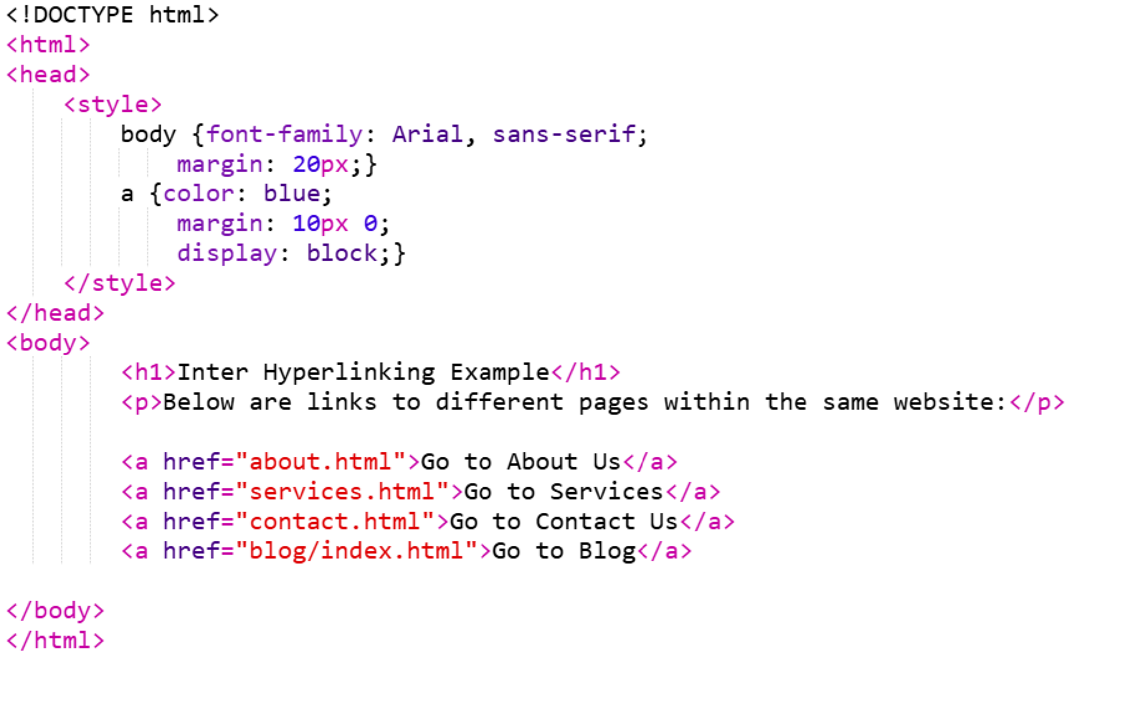

OUTPUT:

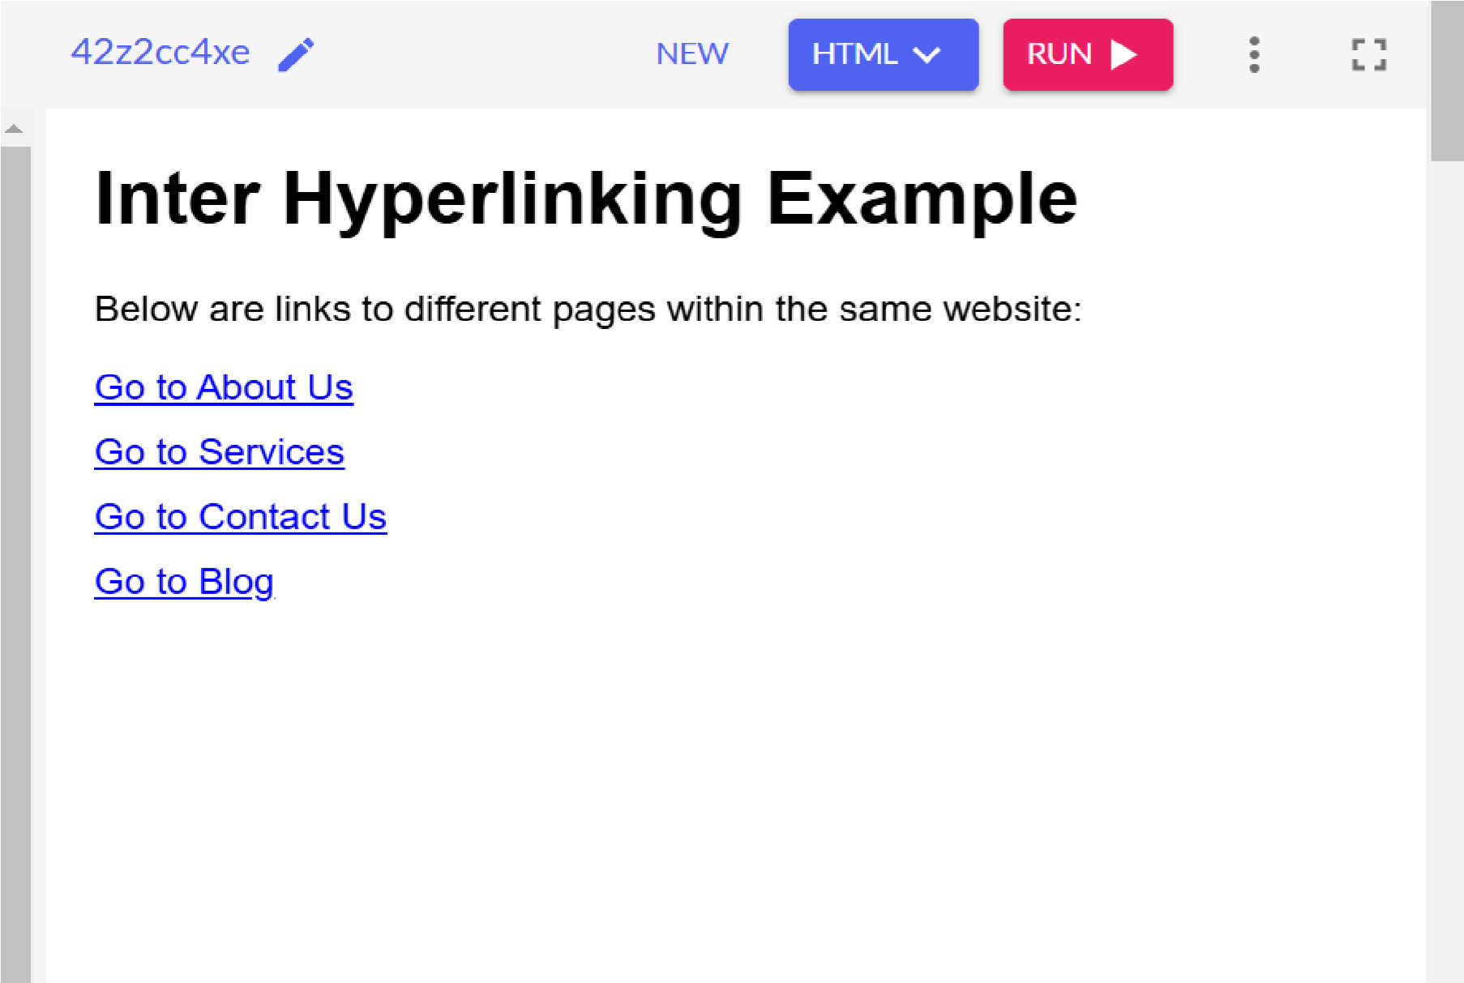

Write code to show external css with html code.

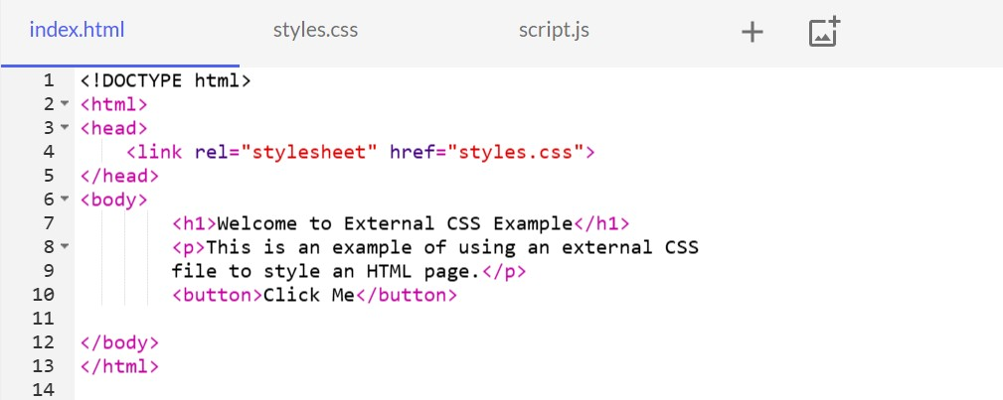

CSS:

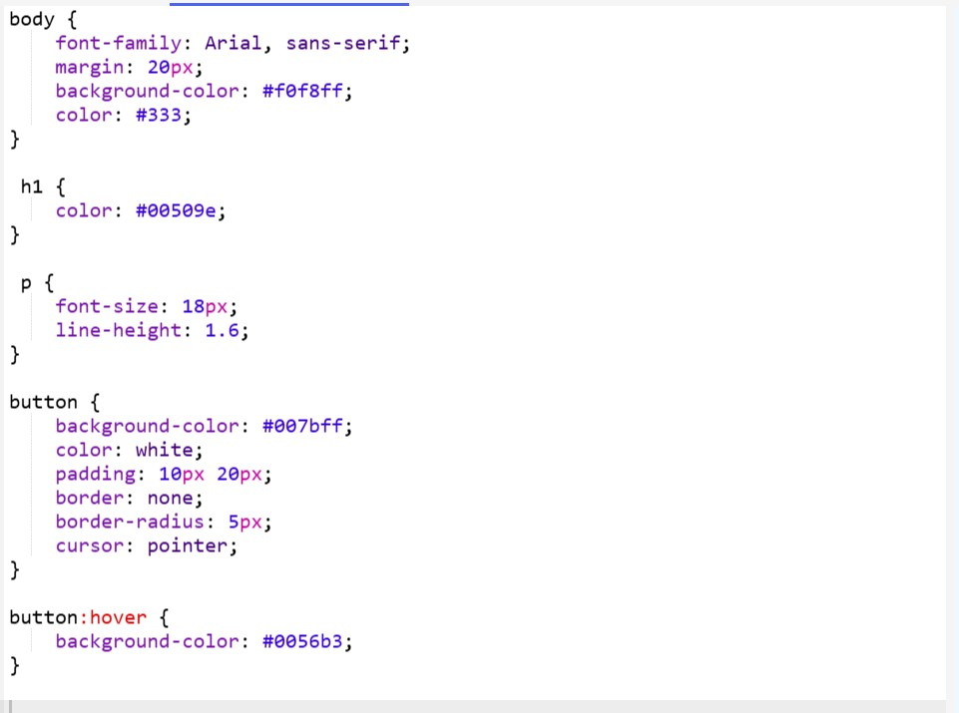

OUTPUT:

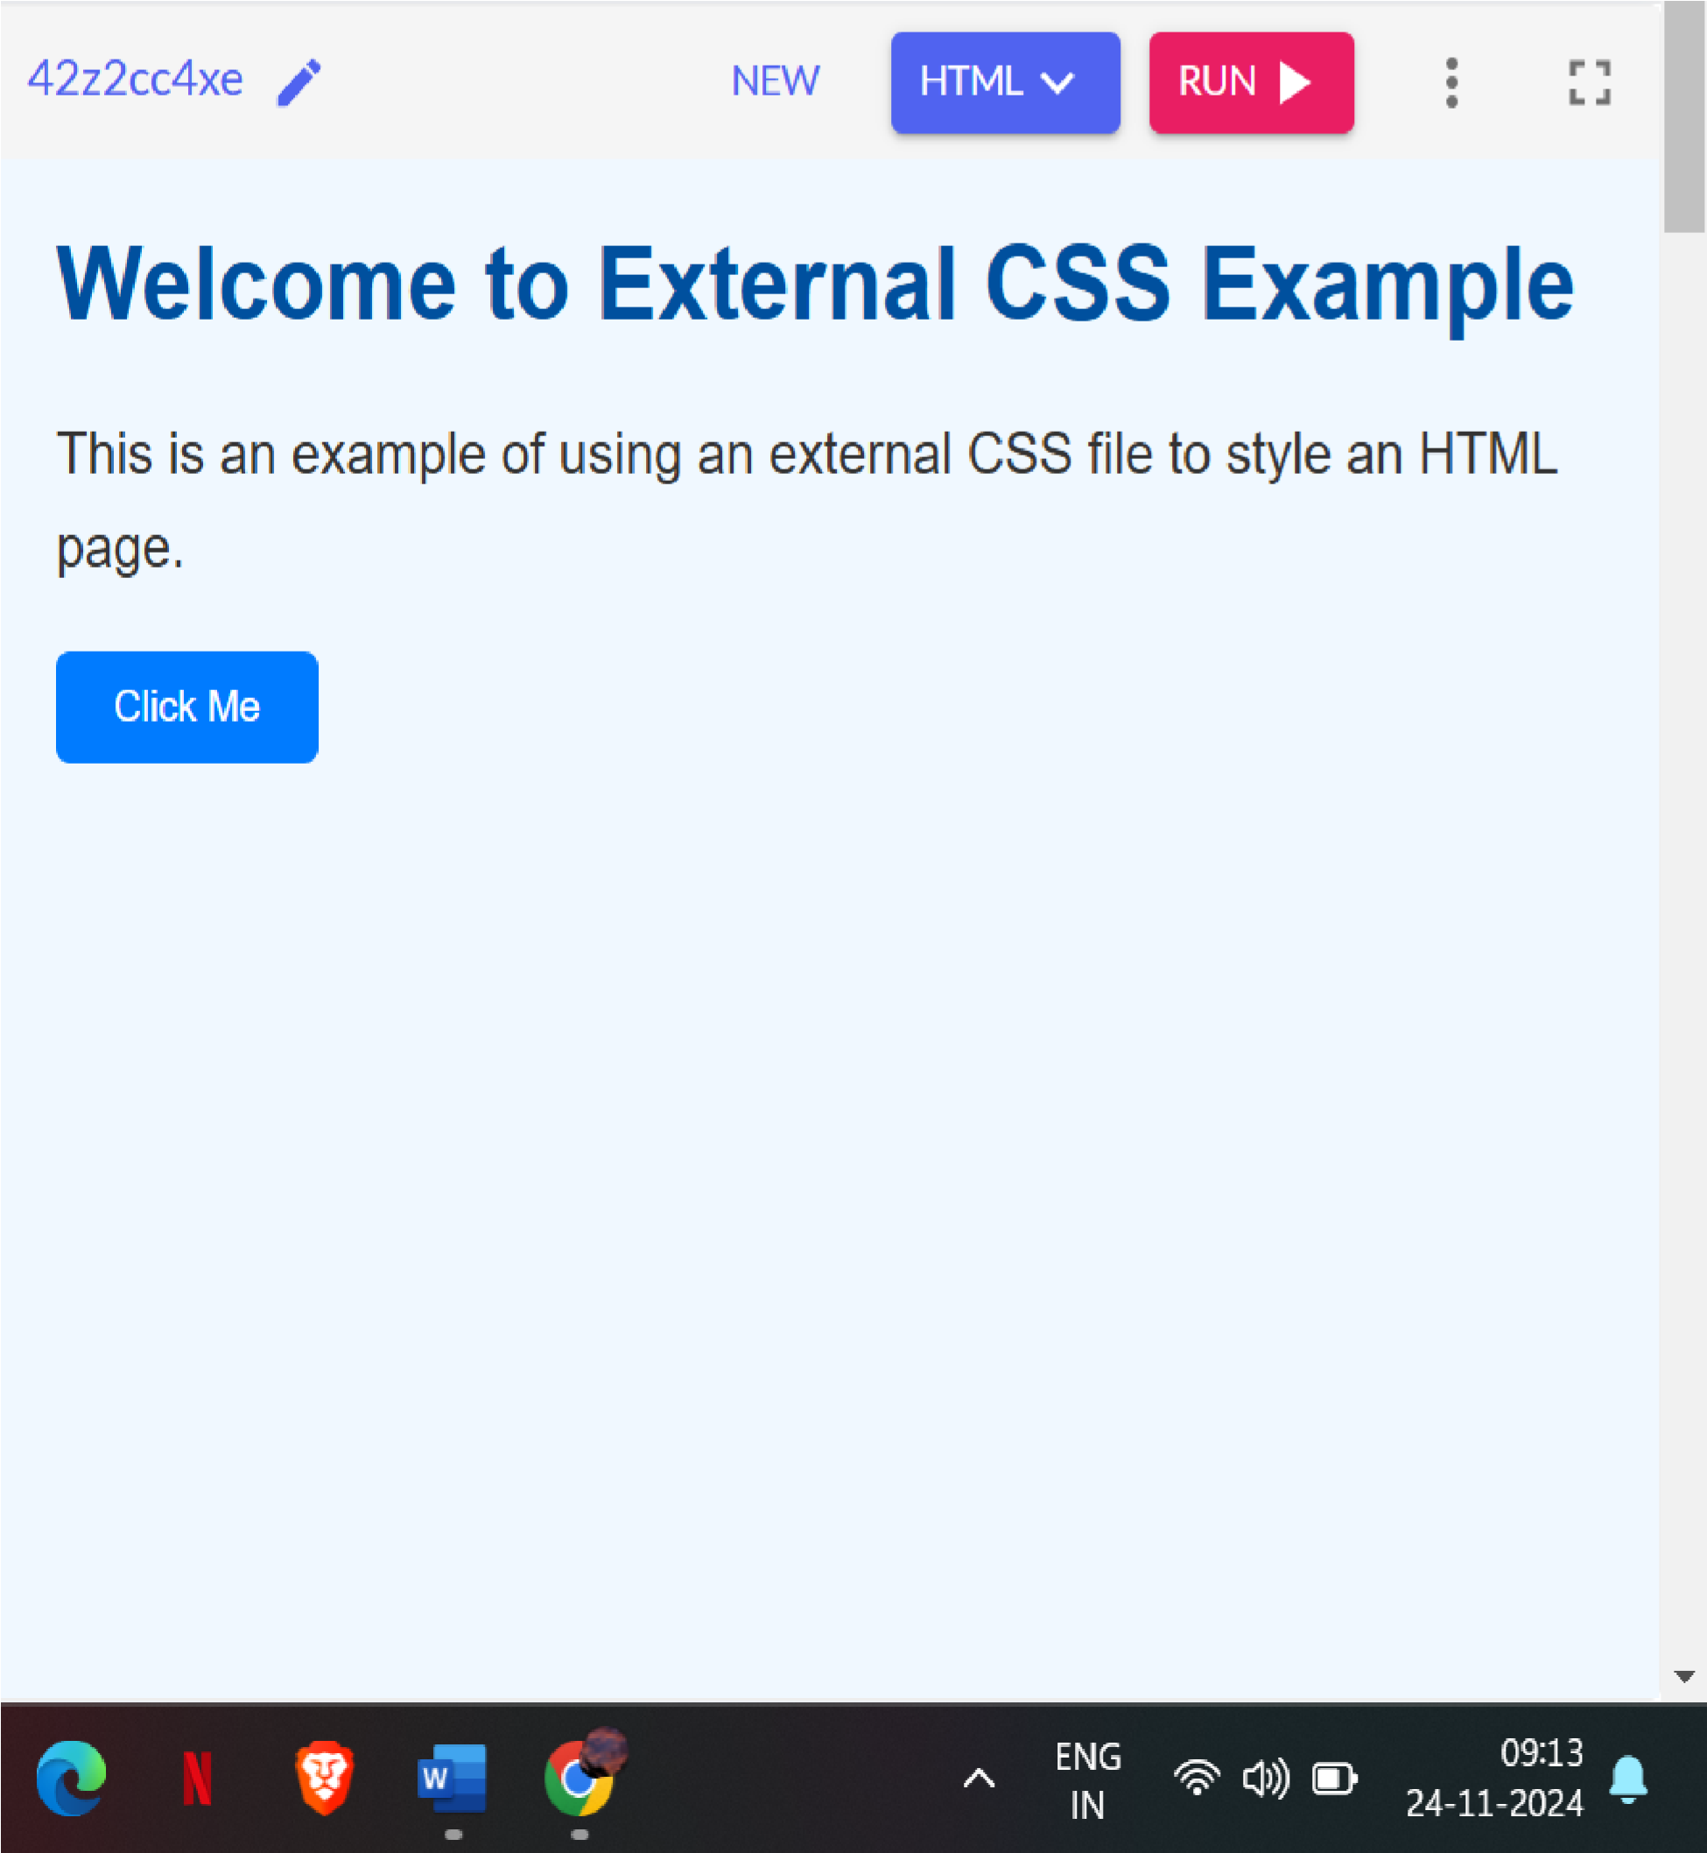

**EXERCISE 25**

Write code to show internal css with html code.

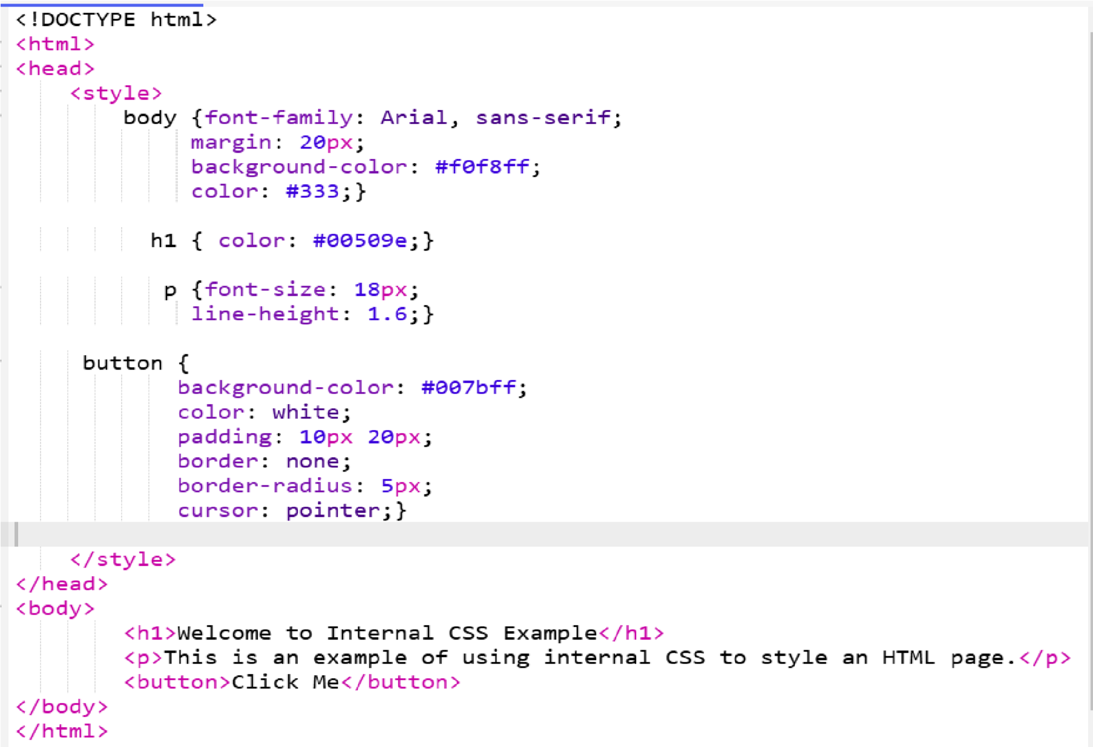

OUTPUT:

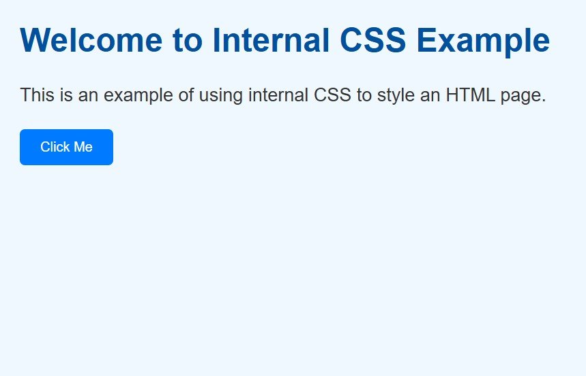

Write code to show inline css with HTML code.

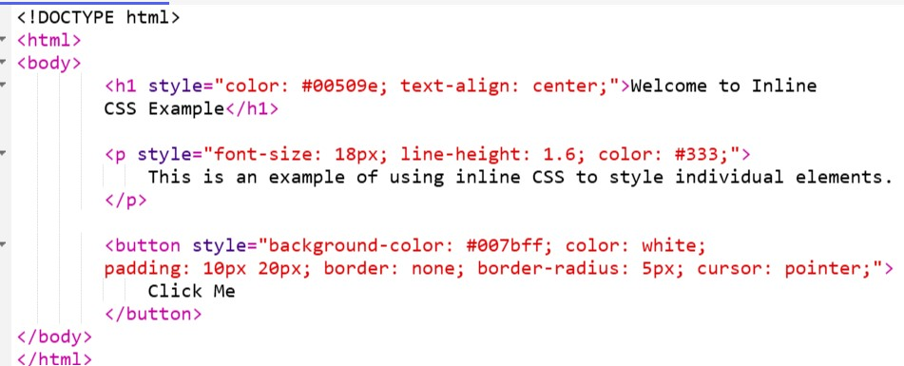

OUTPUT:

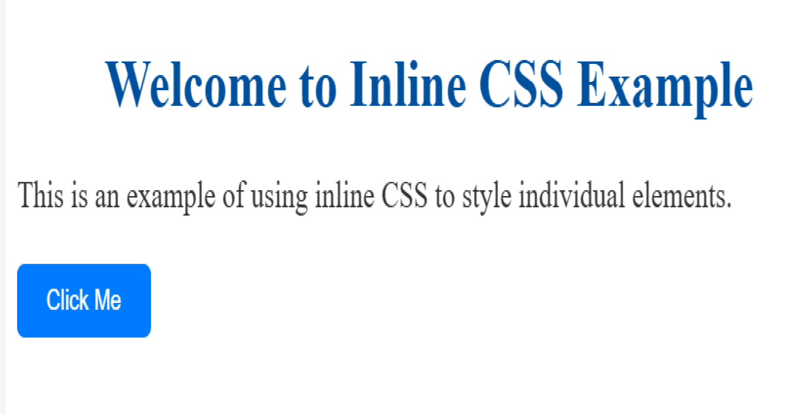

**EXERCISE 27**

Write a program to add two numbers using form in JavaScript.

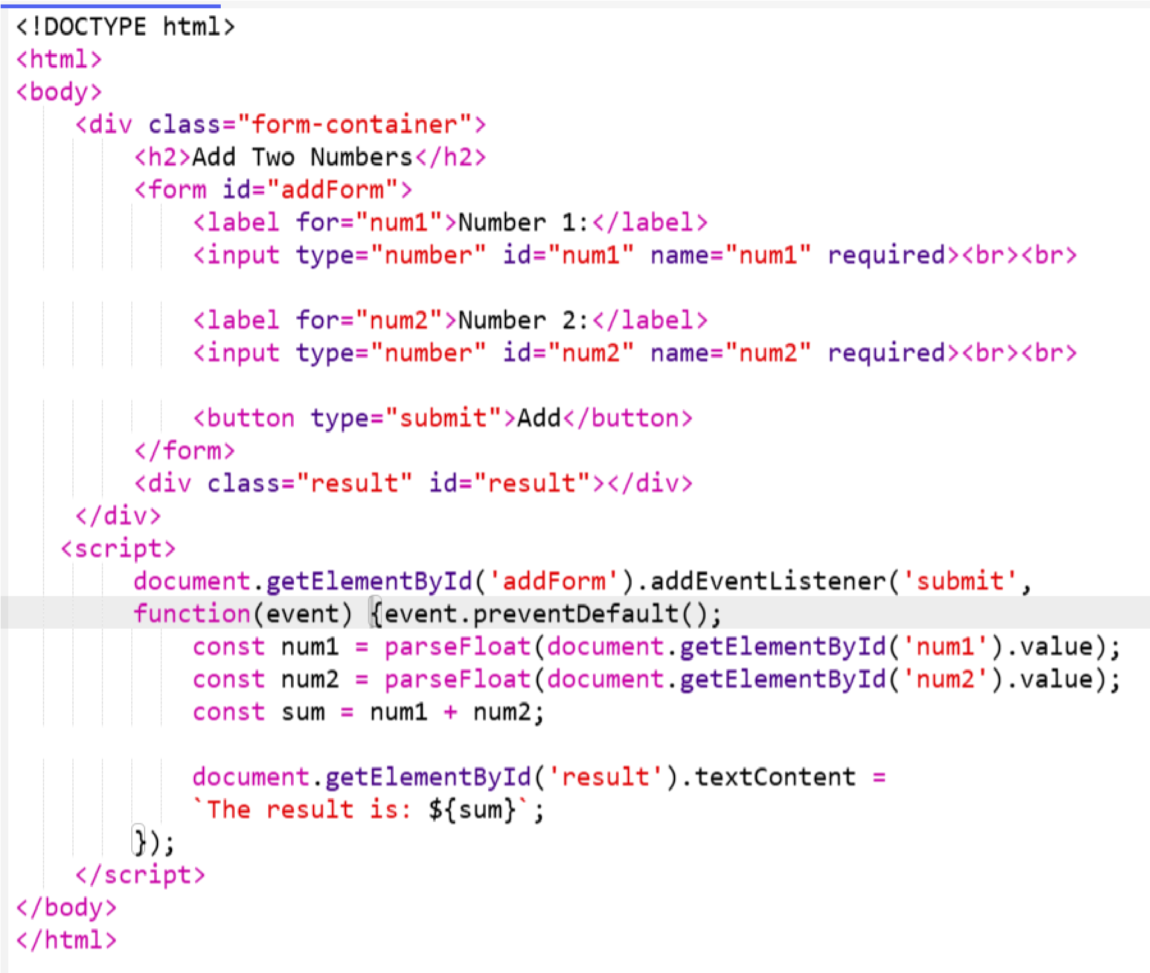

OUTPUT:

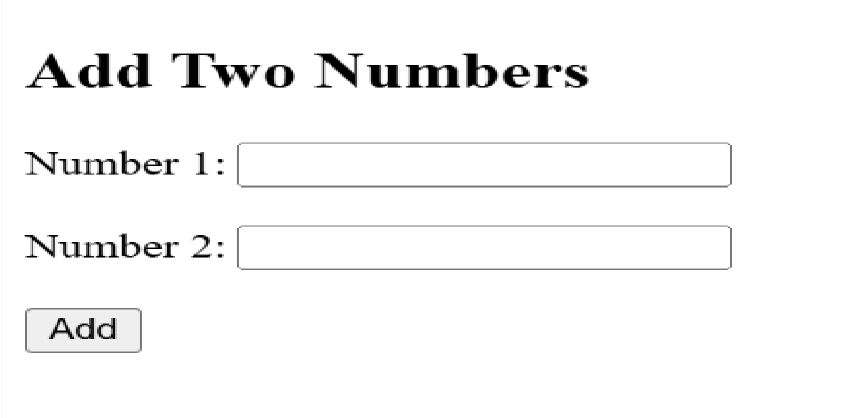

Write a program in JavaScript to swap two images using on mouseover event.

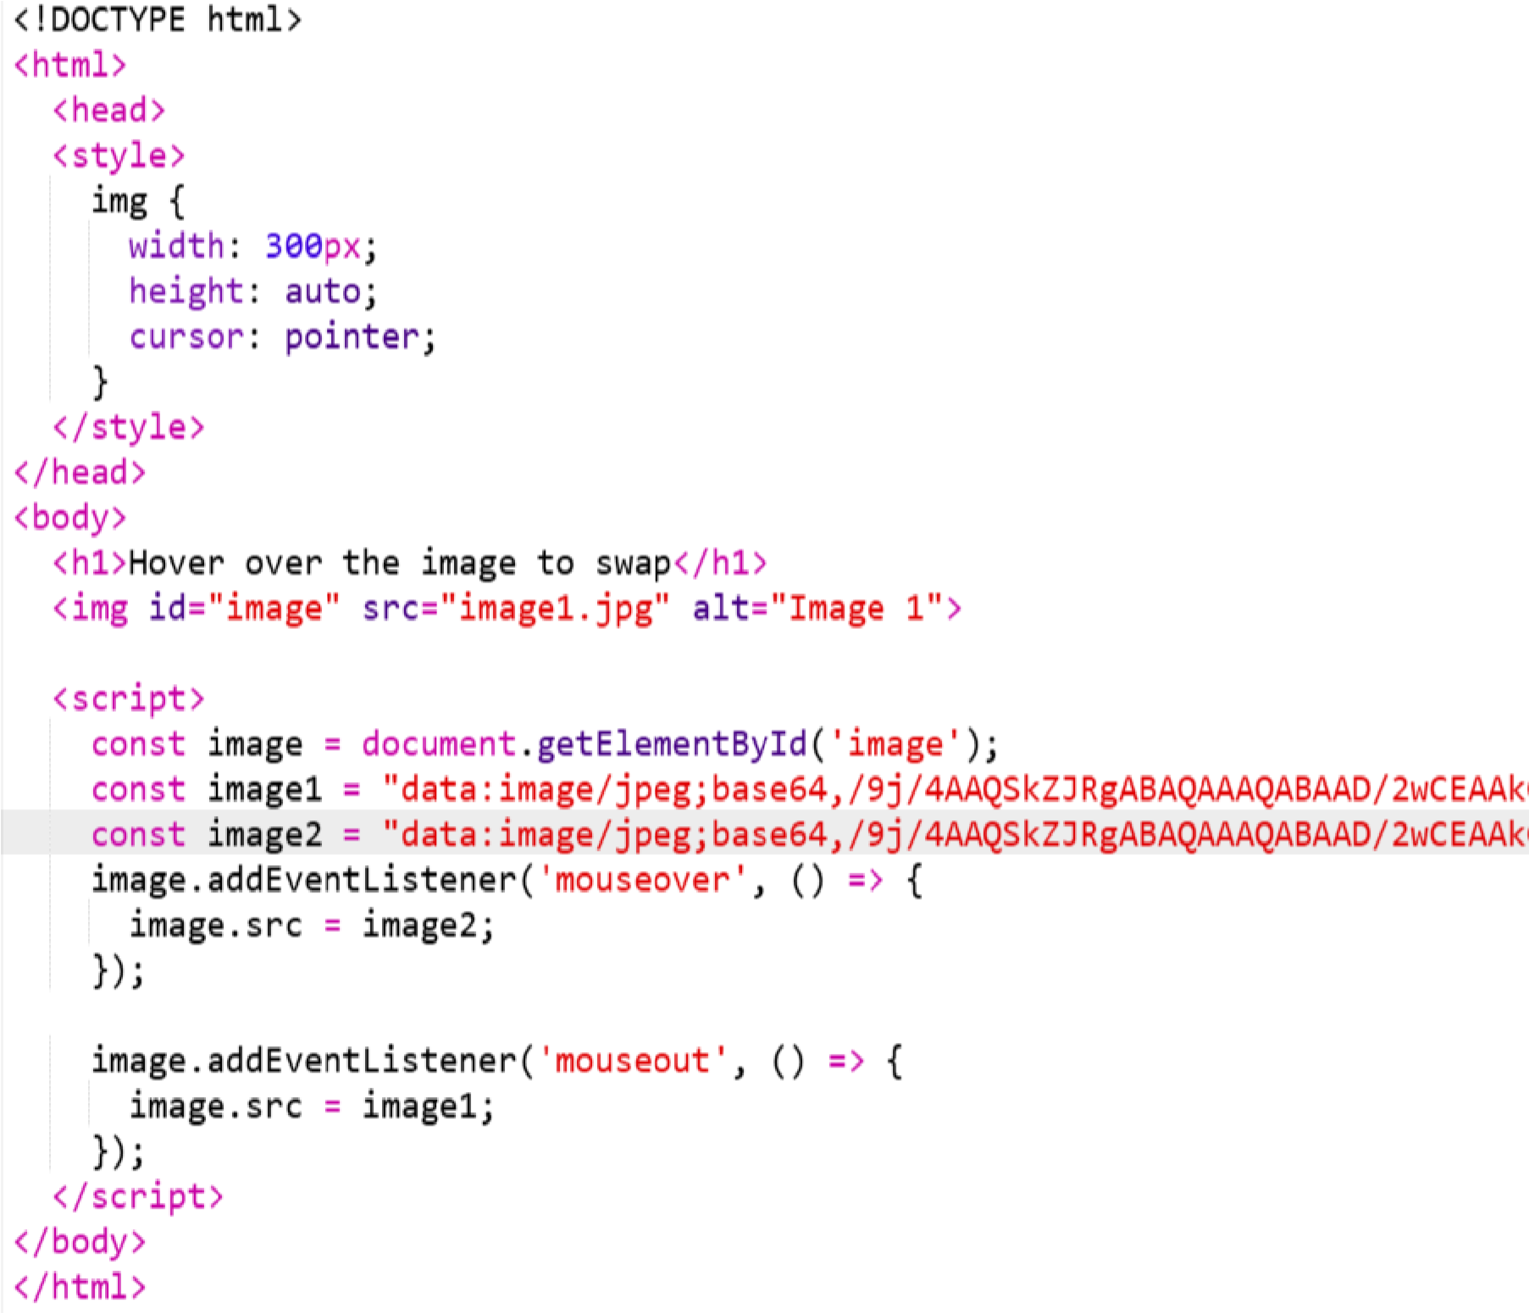

OUTPUT:



Write a simple java script program to write an array

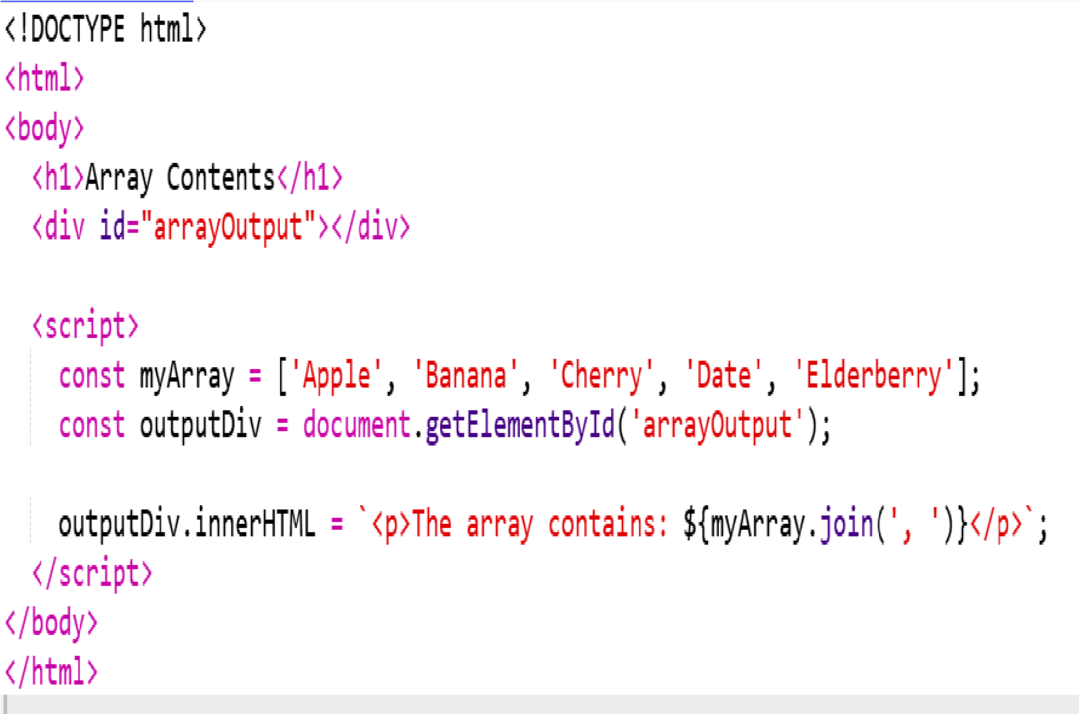

OUTPUT:

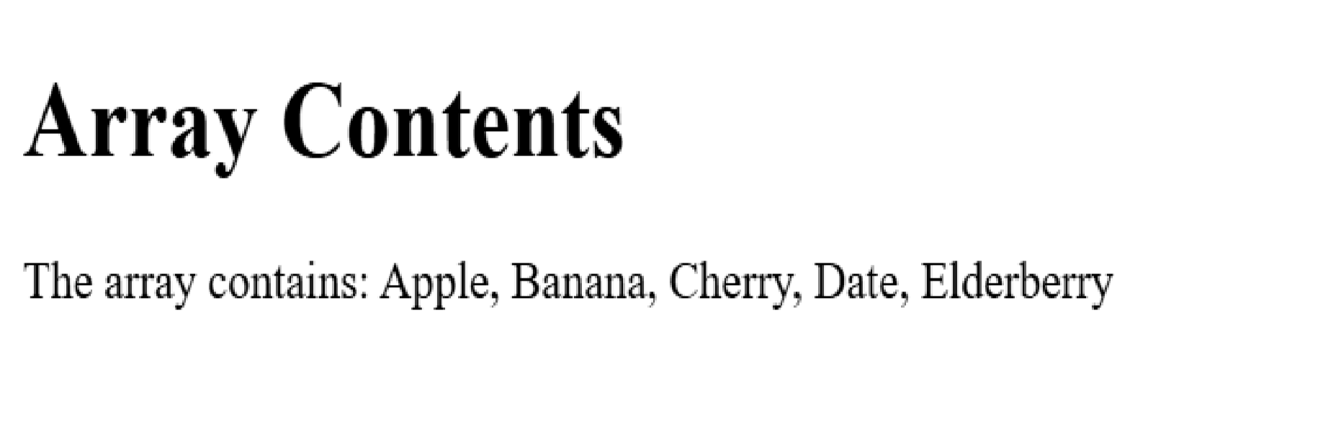

Write a JavaScript program to take as input three numbers from the user .Find the minimum amd maximum of the three numbers. Print the following output in BOLD in following format:

MINIMUM= MAXIMUM=

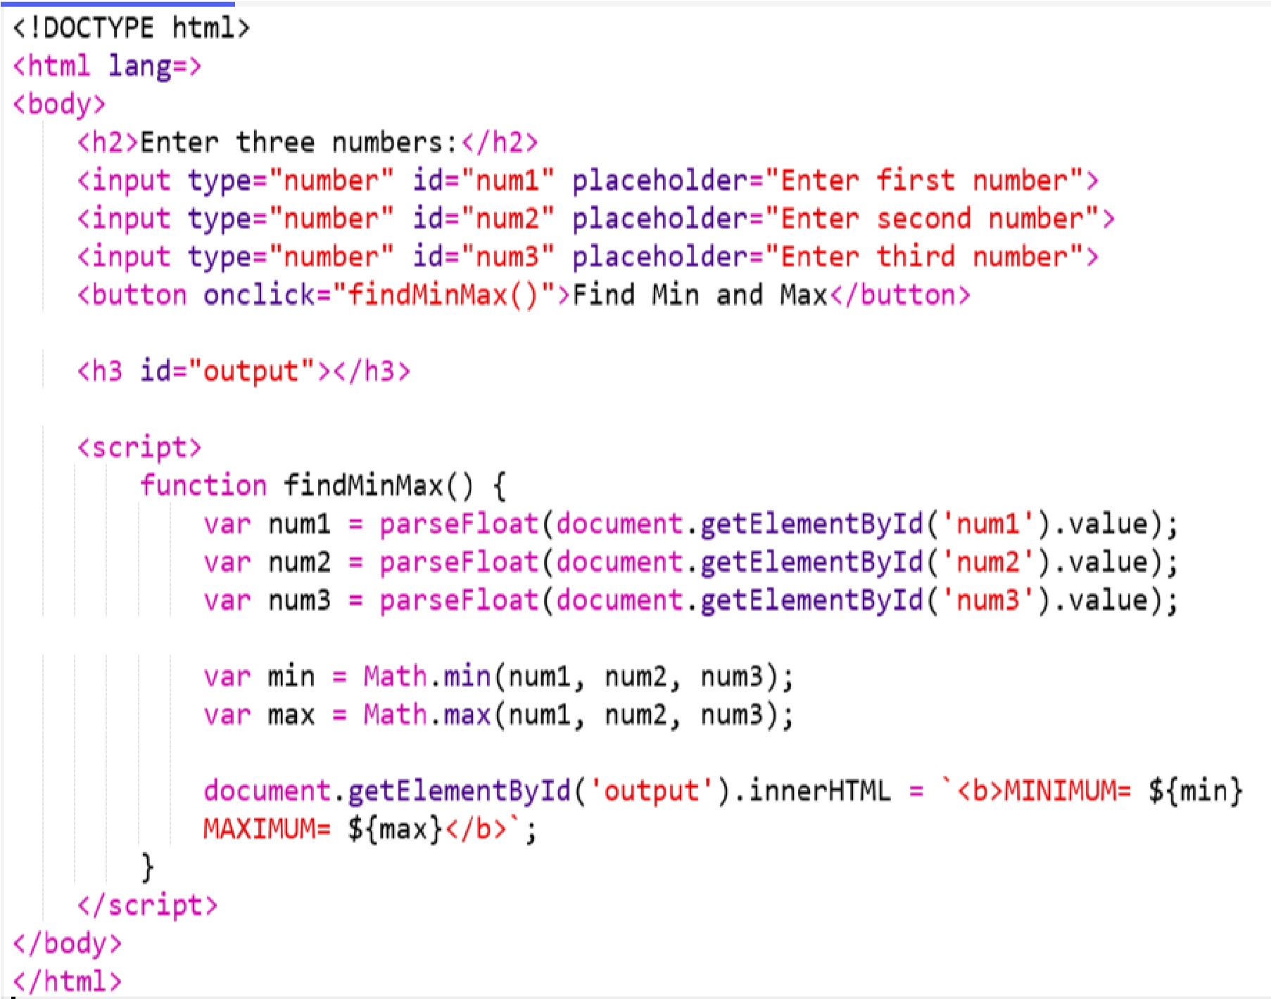

OUTPUT:

